**Smart course Management**

**System in cloud**

Software Requirement Specification

By

**Mr. Chaichan Suttee 542115016**

**Mr. Tanadol Parn-ong 542115021**

Department of Software Engineering

College of Arts, Media and Technology

Chiang Mai University

Project Advisor

________________________

**Mrs. Yun Rim Park**

**Document History**

|  |  |  |  |  |  |  |
| --- | --- | --- | --- | --- | --- | --- |
| **Document Name** | **Version** | **Status** | **Date** | **Viewable** | **Reviewer** | **Responsible** |
| **Documents** | | | | | | |
| Smart course management system in the cloud – Requirement_v1.0.docx | Create  Chapter One – Introduction  Chapter Two– Overall Description & Requirement  Chapter Three – Specific Requirement  Chapter Four – Use case description | Draft | 17 May 2014 | CS, TP, YP | CS,TP | TP |
| Smart course management system in the cloud – Requirement_v1.1.docx | Fix  - use case diagram  - add web application document. | Draft | 17 May 2014 | CS, TP, YP | CS,TP | TP |

**\*CS = Chaichan Suttee**

**\*TP = Tanadol Parn-ong**

**\*YP = Yun Rim Park**

# **Chapter One | Introduction**

## **Purpose**

The purpose of this Software Requirement Specification (SRS) is to describe the functional requirement. The functional requirements depend on the stakeholders e.g. Lecturer, Student. They have current problems that are not met. The requirements in this document explain how the system should solve those problems and help potential users perform their tasks. This document will encourage the users, developers, and who read this document to understand the detail of each requirement.

## **Software Scope**

The scope of application use is designated by the user’s requirements. Smart course management system in the cloud is accessible via web browser in order to provide convenience to lectures and students. Moreover, web browser can provide convenience to administrators. Features of the system can be divided for three types of users:

1. Administrator handles user registration and course management (e.g. creating courses, adding a lecturer and students in the course, and creating semesters).
2. Lecturer handles score management, assignment and quiz management, shares course materials, and sends out notifications to students.
3. Student handles taking assignment and quiz, viewing score, downloading course materials, and checking notifications from lecturers.

The users must register before operating the activities in the system. The users who use this system must be a member user of the system. Also, the status of users can be changed when they login to the system via a web application.

## **Operation Environment**

Smart course management system in the cloud is developed in form of web application. The users have to connect to the internet and access the system via a web browser.

## **1.4 Definition, Acronyms add Abbreviation**

**1.4.1 Key Definition**

**Requirement** (1) A condition or capability needed by a user to solve a problem or achieve an objective. (2) A condition or capability that must be met or possessed by a system or system component to satisfy a contract, standard, specification, or other formally imposed document. (3) A documented representation of a condition or capability as in definition (1) or (2). [IEEE90]

**Feature** Transformation of input parameters to output parameters based on a specified algorithm. It describes the functionality of a product in the language of the product. Used for requirements analysis, design, coding, testing or maintenance. [IEEE90]

**Use Case** (1) Concept to describe a system based on usage of system resources by its environment. Characterized by an objective set of interactions within and at the borders of that system. (2) Notation from UML for describing a scenario (Usage approach, operational scenario) from the perspective of tis users. [IEEE90]

**1.4.2 Key Acronyms and Abbreviation**

**URS XX.Y**  User Requirement Specification number XX.Y

**SRS XX.Y** Software Requirement Specification number XX.Y

**UC XX.Y** Use Case Description number XX.Y

*** XX is mean the number of items

Y is mean the number of devices. 1 = web application, 2 = mobile application

# **Chapter Two | Overall Description & Requirement**

## **2.1 Product Perspective**

Smart course management system in the cloud is a tool for Lecturer and Student interact in studying together. The system helps Lecturer manage his/her course is easily. Also, it help Student access some information or take activities about course easily. The system is accessible via web browser in order to provide convenience to users.

## **2.2 User Characteristics**

The system supports three types of users:

1. Administrator handles user registration and course management (e.g. creating courses, adding a lecturer and students in the course, and creating semesters).
2. Lecturer handles score management, assignment and quiz management, shares course material, and sends out notifications to Student.
3. Student handles taking assignment and quiz, viewing score, downloading course materials, and checking notifications from Lecturer.

## **2.3 Features**

**There are three types of users:**

- Administrator

- Lecturer

- Student

**Feature#1 User registration**

**Description:** This feature supports registration of users for using the system.

**Users:** Lecturer, Student, Administrator

**Details:**

**1-1 Lecturer/Student:** Lecturer/Student can request to register in the system.

**1-2 Administrator:** Administrator can approve registration requests from Lecturers and Students.

**Feature#2 Login to the system**

**Description:** This feature supports access to the system.

**Users:** Lecturer, Student, Administrator

**Details:**

**2-1 Lecturer/Student/Administrator:** User can login to the system.

**2-2 Lecturer/Student/Administrator:** User can logout from the system.

**Feature#3 Course management**

**Description:** This feature supports managing semesters by Administrator to respond academic year that changes over time. Lecturer manages his/her courses offered in each semester. Student accesses course information registered.

**Users:** Administrator, Lecturer, Student

**Details:**

**3-1 Administrator:** Administrator can create, edit, and delete semesters.

**3-2 Administrator:** Administrator can create, edit, and delete a course in the semester.

**3-3 Administrator:** Administrator can register a list of students to a course.

**3-4 Lecturer:** Lecturer can access information of his/her course.

**3-5 Student:** Student can access information of his/her course registered.

**Feature#4 Assignment and Quiz management**

**Description:** This feature supports assignment and quiz management by Lecturer. This feature can process Student’s answer to each question of an assignment or quiz and compute the score. Moreover, this feature supports preventing Student from copying assignments or quizzes which are multiple choices and true/false questions by randomizing the order of questions.

**Users:** Lecturer

**Details:**

**4-1 Lecturer:** Lecturer can assign, edit and delete assignments or quizzes which are multiple choices, true/false questions, or short answers.

**4-2 Lecturer:** Lecturer can limit access to the assignment or quiz of authority.

**4-3 Lecturer**: Lecturer can review overall student’s answer in each choice of assignment or quiz in chart format.

**4-4 Lecturer:** Lecturer can post an assignment or a quiz.

**4-5 Lecturer:** Lecturer can check whether the assignments are submitted in time.

**4-6 Lecturer:** Lecturer can randomize the order of questions in an assignment or a quiz.

**Feature#5 Taking assignments and quizzes**

**Description:** This feature supports taking assignments and quizzes by Student.

**Users:** Student

**Details:**

**5-1 Student:** Student can take assignments or quizzes which are multiple choices, true/false questions, or short answers

## **2.4 Functional & User Requirement**

**URS1.1. Lecturer can register to the system**

**SRS 1-1.1:** The system shall redirect to Lecturer registration page on the web application.

**SRS 1-2-1:** The system shall redirect to Lecture main page on the web application.

**SRS 1-3.1:** The system shall provide Lecturer registration interface on the web application, including lecturer ID, lecturer username, lecturer password, lecturer name, lecturer faculty, lecturer department, lecturer email, and lecturer tel for Lecturer register to the system.

**SRS 1-4.1:** The system shall store the Lecturer personal information into the system after Lecturer submitted his/her register information from Lecturer registration interface on the web application.

**SRS 1-5.1:** The system shall display “Registration Successful” message when Lecturer registered the Lecturer account in Lecturer registration interface on the web application.

**SRS 1-6.1:** The system shall validate the format of the Lecturer personal information after the Lecturer submitted his/her information from Lecturer registration interface on the web application.

**SRS 1-7.1:** The system shall display “The Lecturer ID must be the number only” when the lecturer ID format is wrong.

**SRS 1-8.1:** The system shall display “The Lecturer’s username must be only 4-16 alphabet characters” when the lecturer username format is wrong.

**SRS 1-9.1:** The system shall display “The Lecturer’s password must be only 4-16 characters” when the lecturer password format is wrong.

**SRS 1-10.1**: The system shall display “The Lecturer’s name must be the combination of alphabet and space only” when the lecturer name format is wrong.

**SRS 1-111:** The system shall display “The Lecturer’s tel must be number only” when the lecturer tel format is wrong.

**SRS 1-12.1:** The system shall display “The Lecturer’s email must be the character and only one @ symbol” when the lecturer email format is wrong.

**SRS 1-13.1:** The system shall validate the duplication of the lecturer username after Lecturer submitted his/her information from Lecturer registration interface on the web application.

**SRS 1-14.1:** The system shall display “Existing Lecturer’s username, please using different Lecturer’s username” when the lecturer username duplicates exist lecturer username.

**URS2.1 Student can register to the system**

**SRS 2-1.1:** The system shall redirect to Student registration page on the web application.

**SRS 2-2.1:** The system shall redirect to Student main page on the web application.

**SRS 2-3.1:** The system shall provide Student registration interface on the web application, including student ID, student username, student password, student name, student address, student faculty, student department, student email, and student tel for Student register to the system.

**SRS 2-4.1:** The system shall store the Student personal information into the system after Student submitted his/her register information from Student registration interface on the web application.

**SRS 2-5.1:** The system shall display “Registration Successful” message when Student registered the Student account in Student registration interface on the web application.

**SRS 2-6.1:** The system shall validate the format of the Student information after the Student submitted his/her information from Student registration interface on the web application.

**SRS 2-7.1:** The system shall display “The Student ID must be the number only” when the student ID format is wrong.

**SRS 2-8.1:** The system shall display “The Student’s username must be only 4-16 alphabet characters” when the student username format is wrong.

**SRS 2-9.1:** The system shall display “The Student’s password must be only 4-16 characters” when the student password format is wrong.

**SRS 2-10.1:** The system shall display “The Student’s name must be the combination of alphabet and space only” when the student name format is wrong.

**SRS 2-11.1:** The system shall display “The Student’s tel must be number only” when the student tel format is wrong.

**SRS 2-12.1:** The system shall display “The Student’s email must be the character and only one @ symbol” when the student email format is wrong.

**SRS 2-13.1:** The system shall validate the duplication of the student username after Student submitted his/her information from Student registration interface on the web application.

**SRS 2-14.1:** The system shall display “Existing Student’s username, please using different Student’s username” when the student username duplicates exist student username.

**URS3.1Administrator can approve Lecturer or Student account.**

**SRS 3-1.1:** The system shall redirect to Administrator main page interface.

**SRS 3-2.1:** The system shall redirect to manage account main page interface.

**SRS 3-3.1**: The system shall redirect to the Lecturer account approve page interface

**SRS 3-4.1**: The system shall validate the user status form Administrator.

**SRS 3-5.1:** The system will update the data in database.

**SRS 3-6.1:** The system shall display “Approve Successful” message.

**SRS 3-7.1:** The system shall redirect to the Lecturer account approve page interface.

**URS4.1Lecturer can edit personal information.**

**SRS 4-1.1:** The system shall redirect to Lecturer personal information interface on the web application.

**SRS 4-2.1:** The system shall provide Lecturer personal information interface on the web application, including lecturer password, lecturer name, lecturer faculty, lecturer department, lecturer email, and lecturer tel for Lecturer edits his/her personal information into the system.

**SRS 4-3.1:** The system shall update Lecturer personal information into the system after Lecturer submits to edit his/her personal information from Lecturer personal information interface on the web application.

**SRS 4-4.1:** The system shall display “Editing Information Successful” message when Lecturer edited the Lecturer personal information in Lecturer personal information interface on the web application.

**SRS 4-5.1:** The system shall validate the format of the Lecture personal information after Lecturer submitted his/her personal information from Lecturer personal information interface on the web application.

**SRS 4-6.1:** The system shall display “The Lecturer’s password must be only 4-16 characters” when the lecturer password format is wrong.

**SRS 4-7.1:** The system shall display “The Lecturer’s name must be the combination of alphabet and space only” when the lecturer name format is wrong.

**SRS 4-8.1:** The system shall display “The Lecturer’s tel must be number only” when the lecturer tel format is wrong.

**SRS 4-9.1:** The system shall display “The Lecturer’s email must be the character and only one @ symbol” when the lecturer email format is wrong.

**SRS 4-10.1:** The system shall validate the similarity of password and confirm password after Lecturer submitted his/her personal information from Lecturer personal information interface in the web application.

**SRS 4-11.1:** The system shall display “Password and confirm password is not matched” when password and confirm password is not matched.

**URS5.1 Student can edit personal information.**

**SRS 5-1.1:** The system shall redirect to Student personal information interface on the web application.

**SRS 5-2.1:** The system shall provide Student personal information interface on the web application, including student password, student name, student faculty, student department, student address, student email, and student tel for Student edits his/her personal information into the system.

**SRS 5-3.1:** The system shall update Student personal information into the system after Student submits to edit his/her personal information from Student personal information interface on the web application.

**SRS 5-4.1:** The system shall display “Editing Information Successful” message when Student edited the Student personal information in Student personal information interface on the web application.

**SRS 5-5.1:** The system shall validate the format of the Student personal information after Student submitted his/her personal information from Student personal information interface on the web application.

**SRS 5-6.1:** The system shall display “The Student’s password must be only 4-16 characters” when the student password format is wrong.

**SRS 5-7.1:** The system shall display “The Student’s name must be the combination of alphabet and space only” when the student name format is wrong.

**SRS 5-8.1:** The system shall display “The Student’s tel must be number only” when the student tel format is wrong.

**SRS 5-9.1:** The system shall display “The Student’s email must be the character and only one @ symbol” when the student email format is wrong.

**SRS 5-10.1:** The system shall validate the similarity of password and confirm password after Student submitted his/her personal information from Student personal information interface in the web application.

**SRS 5-11.1:** The system shall display “Password and confirm password is not matched” when password and confirm password is not matched.

**URS6.1 User can log in to the system.**

**SRS 1-2.1:** The system shall redirect to Lecture main page on the web application.

**SRS 2-2.1:** The system shall redirect to Student main page on the web application.

**SRS 3-1.1:** The system displays to Administrator main page interface.

**SRS 6-1.1:** The system shall redirect to Login page on the mobile application.

**SRS 6-2.1:** The system shall provide Login interface on the mobile application, including username and password for Lecturer/Student login his/her account into the system.

**SRS 6-3.1:** The system shall fetch login information of Lecturer/Student from the system to validate the correctness of login information in Login interface on the mobile application.

**SRS 6-4.1:** The system shall display “Invalid Username and/or Password” when username and password are wrong to Lecturer/Student.

**URS7.1 User can log out to the system.**

**SRS 6-1.1:** The system shall redirect to Login page on the mobile application.

**SRS 7-1.1:** The system provides Log out form in all page on the mobile application.

**URS8.1 Administrator can create a semester.**

**SRS 8-1.1:** The system shall redirect to the Semester main page interface.

**SRS 8-2.1:** The system must validate semester academic year information from Administrator.

**SRS 8-3.1:** The system shall store the data in the database table.

**SRS 8-4.1:** The system shall display “Add Semester Successful” message.

**SRS 8-5.1:** The system shall display “Semester academic year must be S/YYYY form, where S is a semester and YYYY is an academic year” message.

**SRS 8-6.1:** The system shall display “The semester and academic year that already exist please type another semester or academic year” message.

**URS9.1 Administrator can edit a semester.**

**SRS 8-5.1:** The system shall display “Semester academic year must be S/YYYY form, where S is a semester and YYYY is an academic year” message.

**SRS 9-1.1:** The system shall redirect to the Edition semester page.

**SRS 9-2.1:** The system must validate semester academic year information from Administrator.

**SRS 9-3.1:** The system shall update the data in the database table.

**SRS 9-4-1:** The system must validate semester academic year information from Administrator.

**SRS 9-5.1:** The system shall display “Editing Semester Successful” message.

**URS10.1 Administrator can delete a semester.**

**SRS 8-1.1:** The system shall redirect to the Semester main page interface.

**SRS 10-2.1:** The system shall display “Deletion Semester Successful” message.

**SRS 10-3.1:** The system shall delete the semester in the database table.

**URS11.1 Administrator can create a course.**

**SRS 11-1.1:** The system shall display Course management page.

**SRS 11-2.1:** The system shall display Course main page.

**SRS 11-3.1:** The system shall display Course Addition page.

**SRS 11-4.1:** The system shall validate course information from Administrator.

**SRS 11-5.1:** The system shall redirects to the Student registration page.

**SRS 11-6.1:** The system shall display “Adding Course Successful” message.

**SRS 11-7.1:** The system shall display “The course credit must be number only” message.

**URS12.1 Administrator can edit a course.**

**SRS 12-1.1:** The system shall display Course information page interface.

**SRS 12-2.1:** The system shall validate course information from Administrator.

**SRS 12-3.1:** The system shall display Update student in course page interface.

**SRS 12-4.1:** The system shall update course information in the database table.

**SRS 12-5.1:** The system shall display “Editing Course Successful” message

**URS13.1 Administrator can delete a course.**

**SRS 12-1.1:** The system shall display Course information page interface.

**SRS 12-2.1:** The system shall validate course information from Administrator.

**SRS 12-3.1:** The system shall display Update student in course page interface.

**SRS 13-1.1:** The system shall display confirm message to delete on the Course information page.

**SRS 13-2.1:** The system shall delete course in the database table.

**SRS 13-3.1:** The system shall display “Deleting Course Successful” message.

**URS14.1 Lecturer can view course information.**

**SRS 14-1.1:** The system shall redirect to Course management page on the mobile application.

**SRS 14-2.1:** The system shall provide all semester on Course management page

**SRS 14-3.1:** The system shall provide all courses name in Course main page on the web application which were taught by finding from lecturer ID.

**SRS 14-4.1:** The system shall redirect to Course main page on the web application.

**SRS 14-5.1:** The system shall redirect to Course information page interface on the web application, including course name, course credit, course description, lecturer name, a list of students in the course.

**SRS 14-6.1:** The system shall fetch the course information from the system to display into Course information page on the web application.

**URS15.1 Student can view course information.**

**SRS 15-1.2:** The system redirects to Semester page interface on the web application.

**SRS 15-2.2:** The system provides all semester on Semester page on the web application which were studied by finding from student ID.

**SRS 15-3.2:** The system redirects to Overall course page on the web application.

**SRS 15-4.2:** The system provides all courses name in Overall course page on the web application which were studied by finding from student ID.

**SRS 15-35.2:** The system redirects to Course information page interface on the web application, including course name, course credit, course description, lecturer name, a list of students in the course.

**SRS 15-6.2:** The system fetches the course information from the system to display into Course information page on the web application.

**URS16.1 Lecturer can assign assignments or quizzes which are multiple choices question, true/false question, and short answers.**

**SRS 16-1.1:** The system shall redirect to Overall testing page on the web application.

**SRS 16-2.1:** The system shall redirect to Addition testing page on the web application.

**SRS 16-3.1:** The system shall provide Addition testing page interface on the web application, including testing name, a type of testing, an amount of questions, a testing score student name, randomize order of the question status, and posting status for Lecturer adds an assignment or quiz into the system.

**SRS 16-4.1:** The system shall validate testing information from Lecturer.

**SRS 16-5.1:** The system shall redirect to Assigning assignment and quiz page on the web application.

**SRS 16-6.1:** The system shall provide Assign assignment and quiz page interface on the web application, including a type of question, question description, choice description, an answer, and a question point for Lecturer assigns assignments or quizzes into the system.

**SRS 16-7.1:** The system shall validate assignment or quiz information from Lecturer.

**SRS 16-8.1:** The system shall store the testing information from Lecturer into the system.

**SRS 16-9.1:** The system shall store assignment or quiz information from Lecturer into the system.

**SRS 16-10.1:** The system shall display “Amount of questions must be number only” message when the amount of questions format is wrong.

**SRS 16-11.1:** The system shall display “Answer must be a, b, c, and d only” message when the multiple choices answer format is wrong.

**SRS 16-12.1:** The system shall display “Answer must be a and b only” message when the true/false answer format is wrong.

**SRS 16-13.1:** The system shall display “Testing score must be number only” message when the testing score format is wrong.

**SRS 16-14.1:** The system shall display “Question point must be number only” message when the question point format is wrong.

**SRS 16-15.1:** The system shall display “Creating Assignment Successful” message when Lecturer assign an assignment is successful.

**SRS 16-16.1:** The system shall display “Creating Quiz Successful” message when Lecturer assign a quiz is successful.

**SRS 16-17.1:** The system shall redirect to confirm creating testing page.

**URS17.1 Lecturer can edit assignments or quizzes information which are multiple choices question, true/false question, and short answers.**

**SRS 16-4.1:** The system shall validate testing information from Lecturer.

**SRS 16-7.1:** The system shall validate assignment or quiz information from Lecturer.

**SRS 16-10.1:** The system shall display “Amount of questions must be number only” message when the amount of questions format is wrong.

**SRS 16-11.1:** The system shall display “Answer must be a, b, c, and d only” message when the multiple choices answer format is wrong.

**SRS 16-12.1:** The system shall display “Answer must be a and b only” message when the true/false answer format is wrong.

**SRS 16-13.1:** The system shall display “Testing score must be number only” message when the testing score format is wrong.

**SRS 16-14.1:** The system shall display “Question point must be number only” message when the question point format is wrong.

**SRS 17-1.1:** The system shall redirect to Edition testing page on the web application.

**SRS 17-2.1:** The system shall redirects to Edition assignment and quiz page on the web application.

**SRS 17-3.1:** The system shall fetch the testing information from the system to display on Edition testing page on the web application.

**SRS 17-4.1:** The system shall fetch the assignment or quiz information from the system to display on Edition assignment and quiz page on the web application.

**SRS 17-5.1:** The system shall provide Edition testing page interface on the web application, including testing name, a type of testing, an amount of questions, a score testing, student name, randomize order of the question status, and posting status for Lecturer adds an assignment or quiz into the system.

**SRS 17-6.1:** The system shall provide Edition assignment and quiz page interface on the web application, including a type of question, question description, choice description, an answer, and a question point for Lecturer assigns assignments or quizzes into the system.

**SRS 17-7.1:** The system shall update the testing information from Lecturer into the system.

**SRS 17-8.1:** The system shall update assignment or quiz information from Lecturer into the system.

**SRS 17-9.1:** The system shall display “Editing Assignment Successful” message when Lecturer edits an assignment is successful.

**SRS 17-10.1:** The system shall display “Editing Quiz Successful” message when Lecturer edits a quiz is successful.

**SRS 17-11.1:** The system shall redirect to confirm edition testing page.

**URS18.1 Lecturer can delete assignments or quizzes which are multiple choices question, true/false question, and short answers.**

**SRS 18-1.1:** The system shall deletes the testing information from the system.

**SRS 18-2.1:** The system shall deletes assignment or quiz information from the system.

**SRS 18-3.1:** The system shall display “Deleting Assignment Successful” message when Lecturer deletes an assignment is successful.

**SRS 18-4.1:** The system shall display “Deleting Quiz Successful” message when Lecturer deletes a quiz is successful.

**URS19.1 Lecturer marks the point for student’s short answer.**

**SRS 19-1.1:** The system shall redirect to Marking the point for student’s short answer page on the web application.

**SRS 19-2.1:** The system shall fetch short answer question and student’s short answer from the system.

**SRS 19-3.1:** The system shall display short answer question and student’s short answer in Marking the point for student’s short answer page on the mobile application.

**SRS 19-4.1:** The system shall validate question point format from Lecturer.

**SRS 19-5.1:** The system shall store point of student into the system.

**SRS 19-6.1:** The system shall display “Marking point is successful” message in Marking the point for student’s short answer page on the web application.

**SRS 19-7.1:** The system shall display “Point of student must be number only” message when the point of student format is wrong.

**URS20.1 Lecturer can review overall student’s answer in each choice of assignment or quiz in chart format.**

**SRS 20-1.1:** The system shall redirect to Chart format of student’s answer page on the web application.

**SRS 20-2.1:** The system shall fetch the assignment or quiz information from the system.

**SRS 20-3.1:** The system shall display overall student’s answer in each choice of assignment or quiz in chart format into Chart format of student’s answer page on the web application.

**URS21.1 Lecturer can check whether the assignments are submitted in time.**

**SRS 21-1.1:** The system shall redirect to testing submission page on the web application.

**SRS 21-2.1:** The system displays testing submission information into testing submission page on the web application which consist student name, student ID.

**URS22.1 Student can take assignments or quizzes which are multiple choices, true/false questions, short answers.**

**SRS 22-1.1:** The system shall redirect to Overall testing page on the web application.

**SRS 22-2.1:** The system shall redirect to Assignment or quiz page on the web application.

**SRS 22-3.1:** The system shall fetch the assignment or quiz information from the system.

**SRS 22-4.1:** The system shall display the assignment or quiz information into Assignment or quiz page on the web application.

**SRS 22-5.1:** The system shall store answers of taking an assignment or quiz into the system.

# **Chapter Three | Specific Requirement**

## **3.1 Use case Diagram**

**3.1.1 Web application Use Case Diagram**

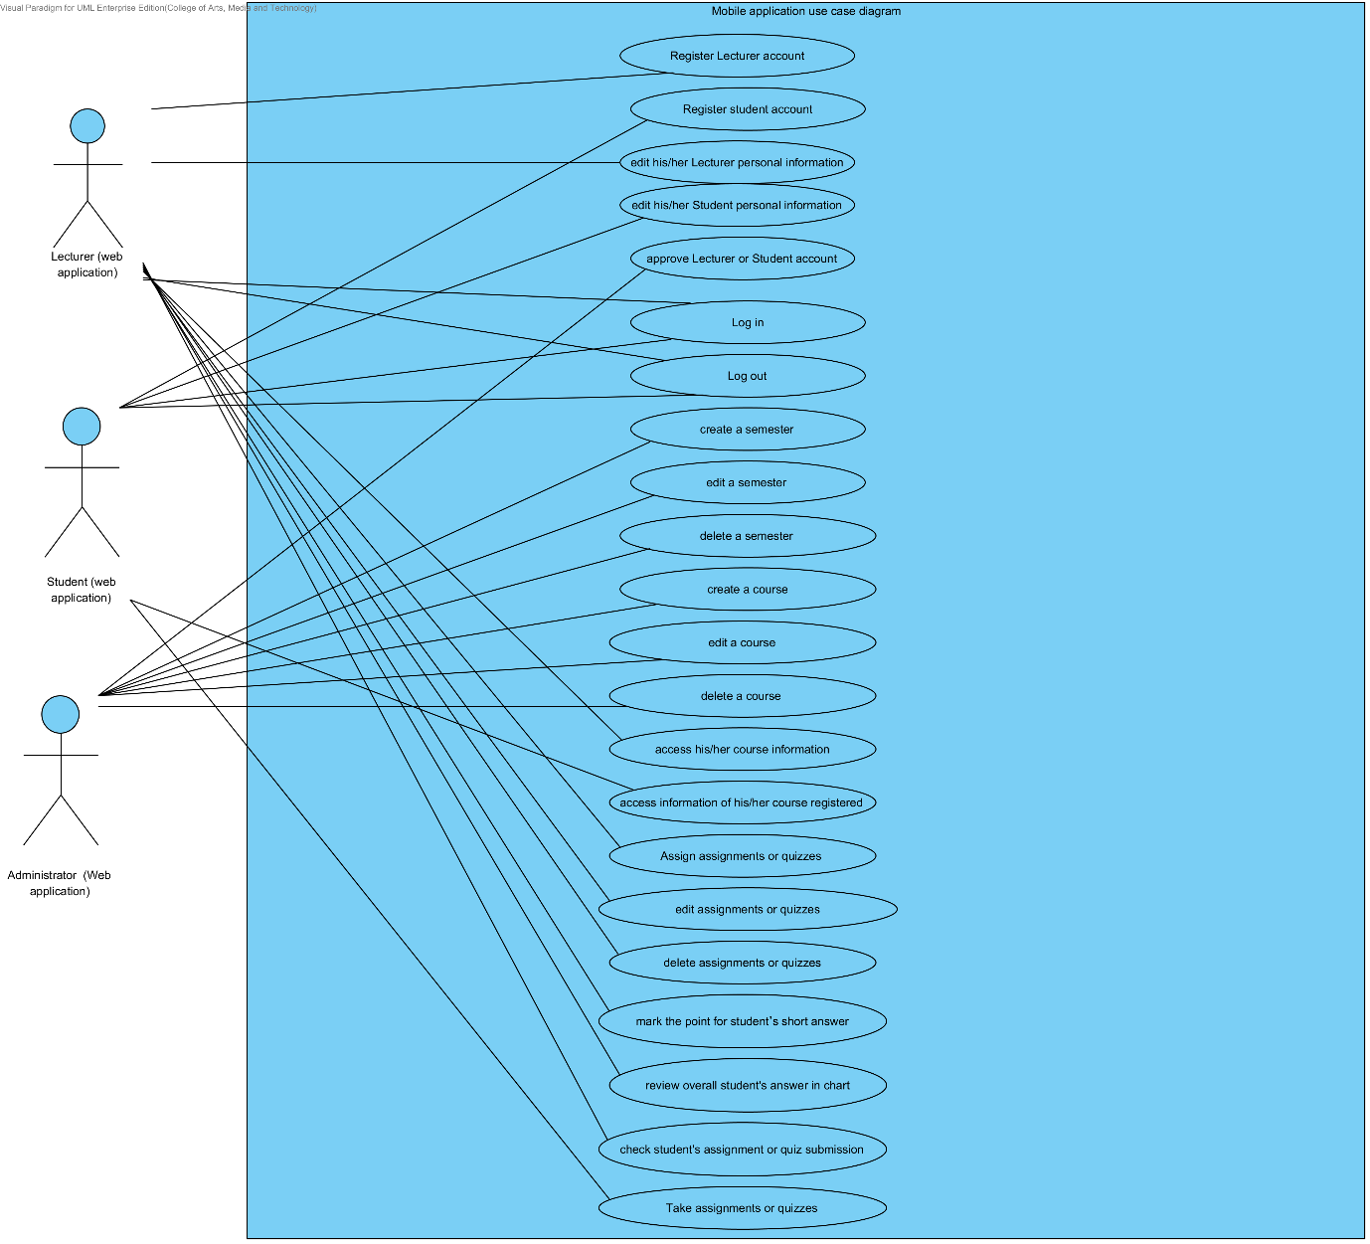

**3.1.2 User Registration Use Case Diagram**\

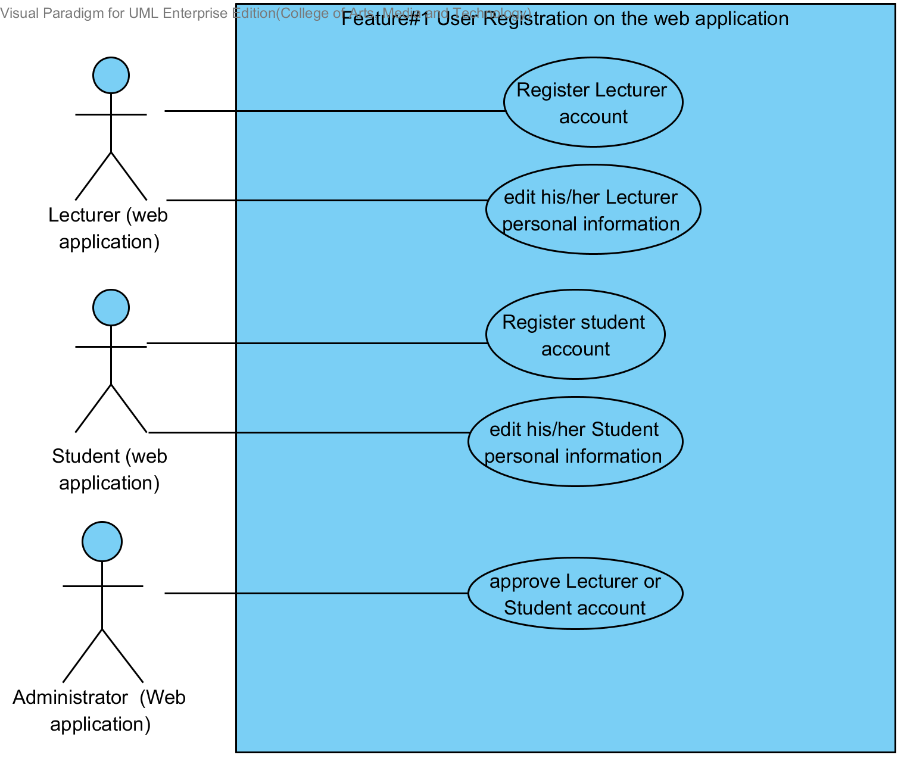

**Description**

The functions in this diagram are registration of Lecturer/Student on the web application for using the system, and approval Lecturer or Student account by Administrator.

**3.1.3 Login to the system Use Case Diagram**

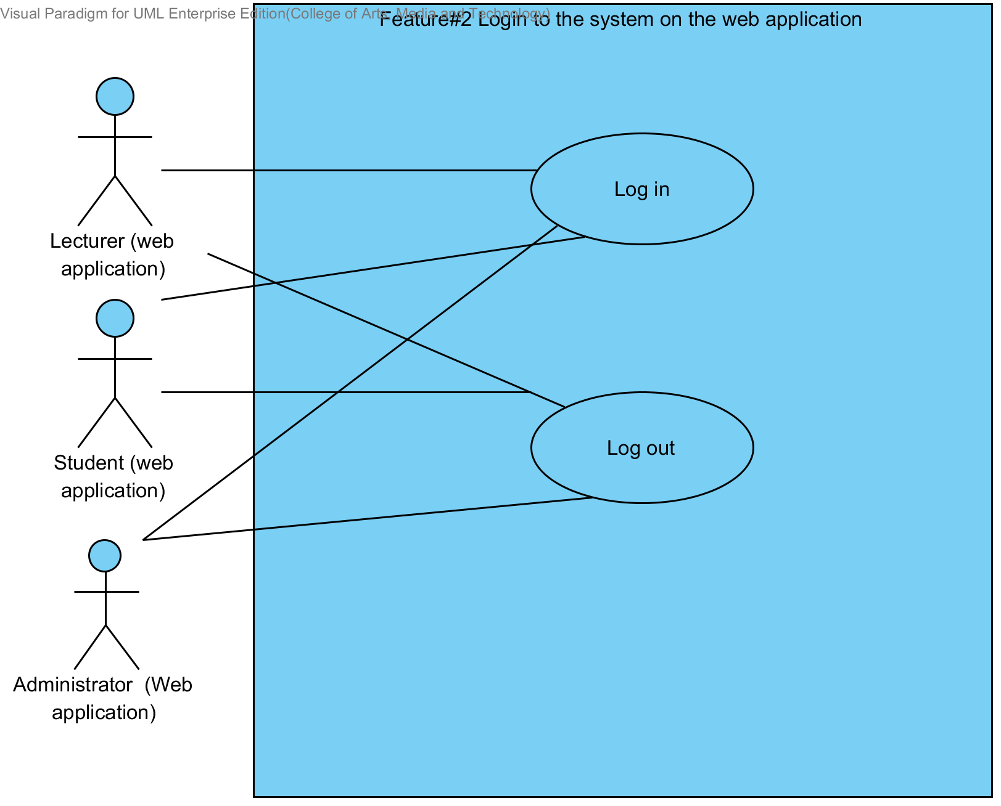

**Description**

The functions in this diagram are accession to the system of users on the web application.

**3.1.4 Course management Use Case Diagram**

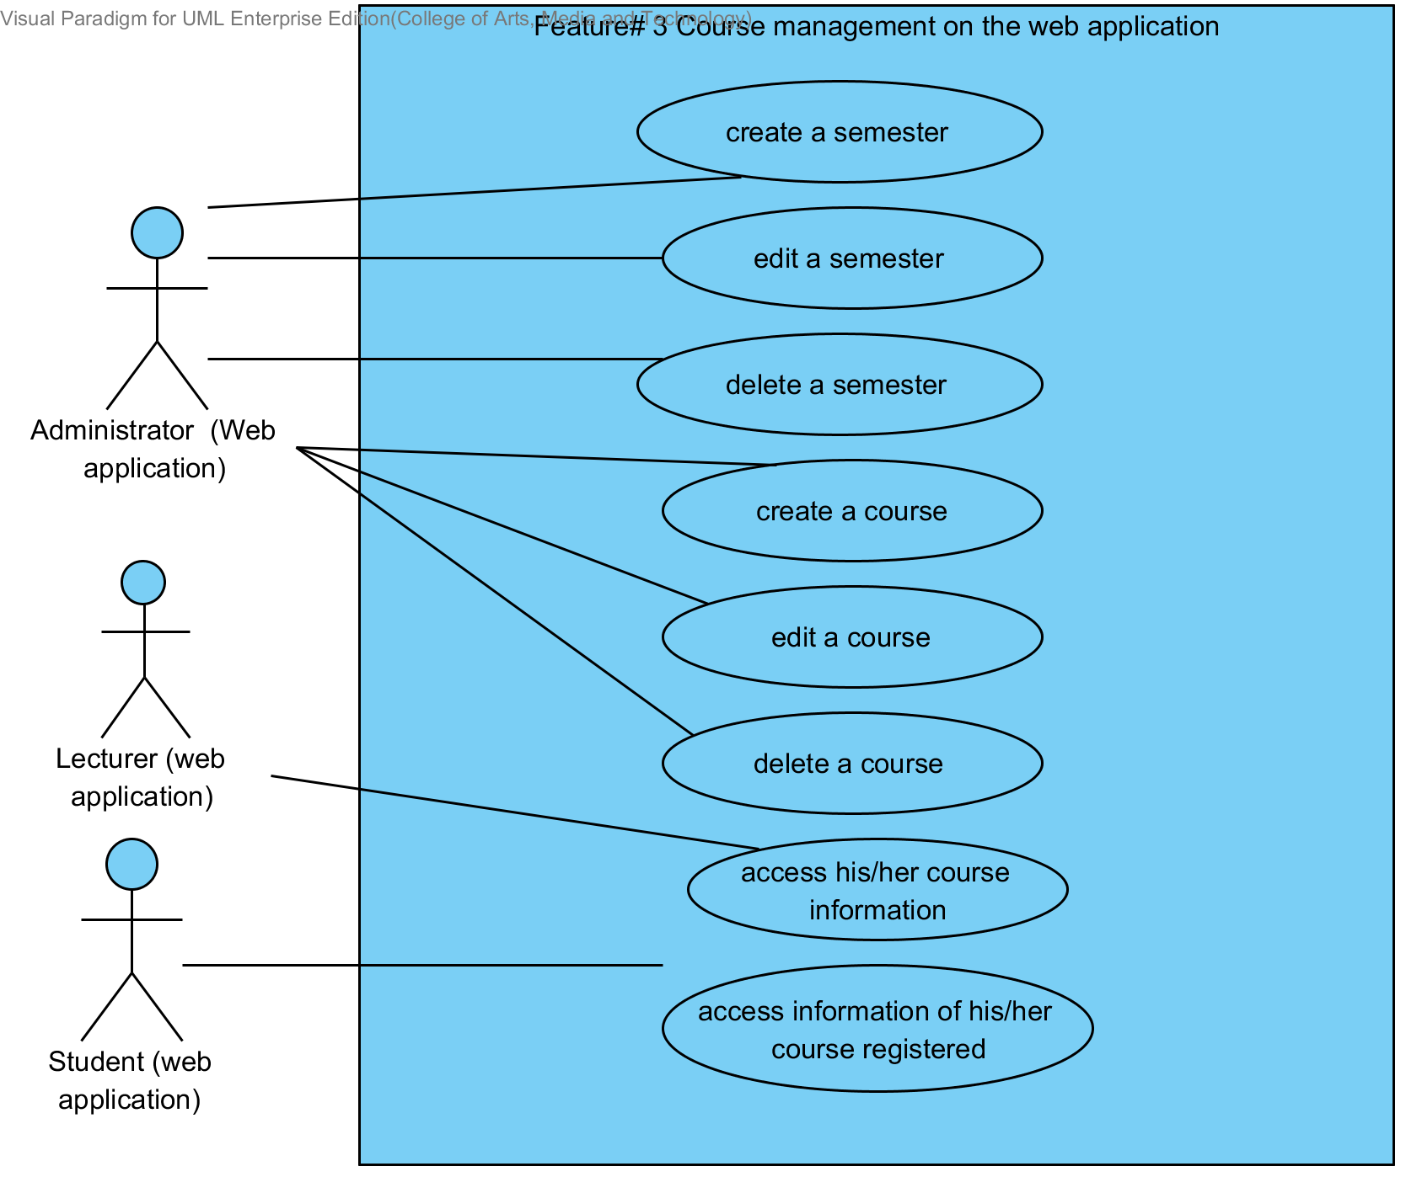

**Description**

The functions in this diagram are course management and semester management by administrator. Moreover, this diagram explains in accession to courses information that were taught by Lecturer on the web application. Student access to courses information that were registered on the web application. Users need login before use the system.

**3.1.5 Assignments and quizzes management Use Case Diagram**

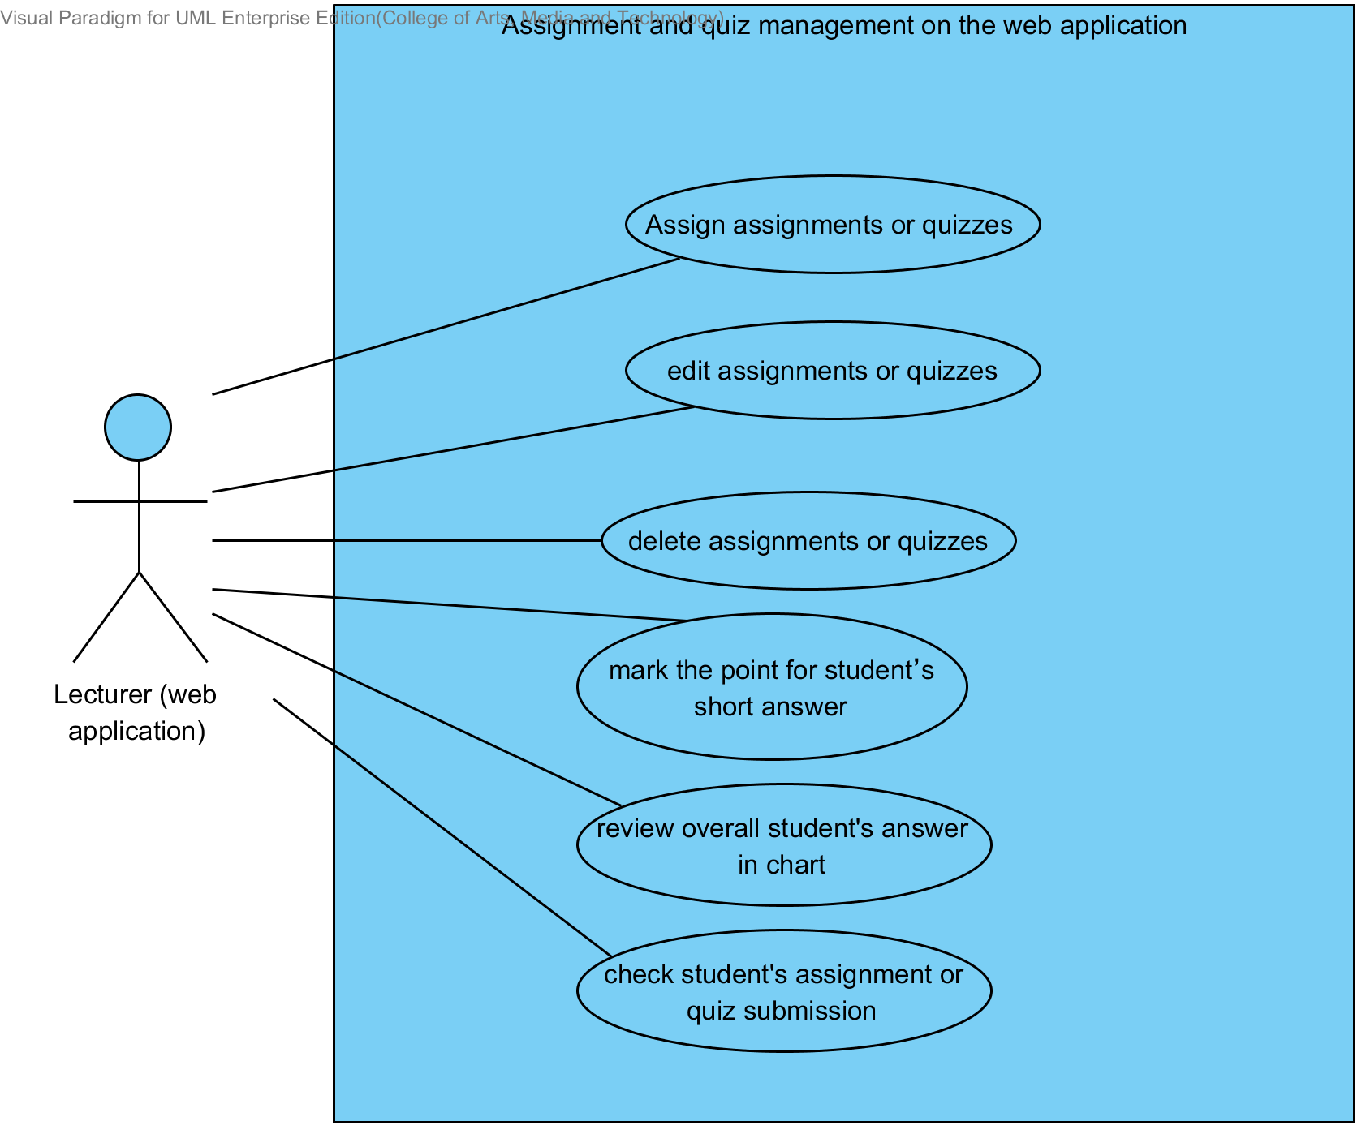

**Description**

The functions in this diagram are assignments and quizzes management by Lecturer on the web application. Which provide assignation assignments or quizzes, edition assignments or quizzes, deletion assignments or quizzes, review overall student’s answer in chart, and checking student submission. Lecturer need login before user the system.

**3.1.6 Taking assignments and quizzes Use Case Diagram**

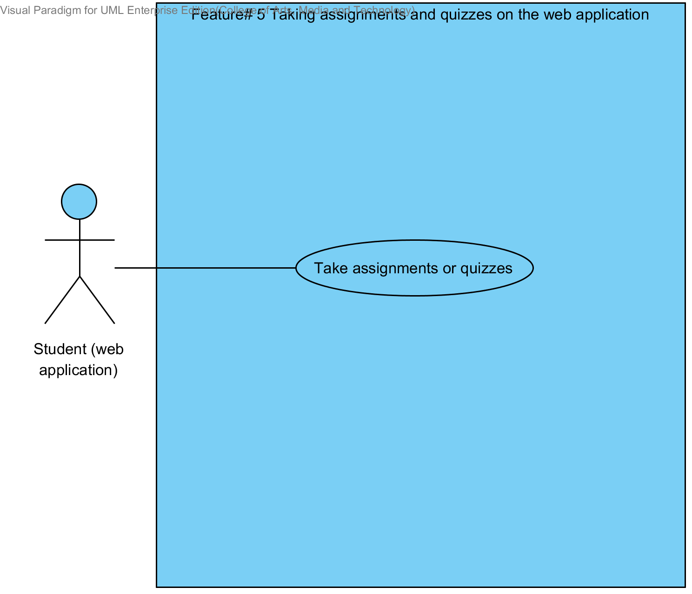

**Description**

The functions in this diagram are taking assignment and quizzes by Student. Student need login before user the system.

# **Chapter Four | Use case description**

## **4.1 Lecturer registers to the system (UC 1.1)**

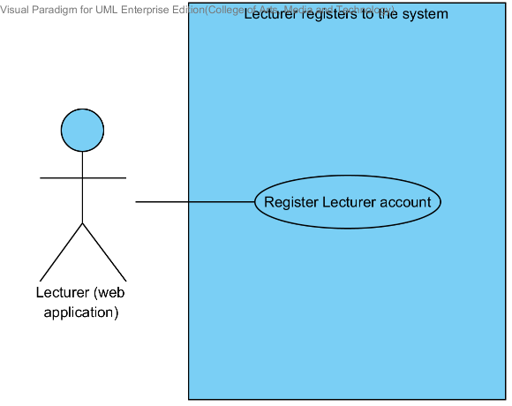

|  |  |  |  |  |
| --- | --- | --- | --- | --- |
| **Use Case ID:** | UC 1.1 | | | |
| **Use Case Name:** | Lecturer registers to the system | | | |
| **Created By:** | Mr.Tanadol Parn-ong | | **Last Updated By:** | Mr.Tanadol Parn-ong |
| **Date Created:** | 10/05/2014 | | **Last Revision Date:** | 10/05/2014 |
| **Actors:** | | Lecturer | | |
| **Description:** | | This use case is provided for Lecturer request to register account to the system on the web application. | | |
| **Trigger:** | | Lecturer enters to Lecturer registration page. | | |
| **Preconditions:** | | N/A | | |
| **Post conditions:** | | Lecturer sees “Registration Successful” message on the web application. | | |
| **Normal Flow:** | | 1. Lecturer enters to Lecturer registration page. 2. The system redirects to Lecturer registration page on the web application. 3. The system provides Lecturer registration interface on the web application, including lecturer ID, lecturer username, lecturer password, lecturer name, lecturer faculty, lecturer department, lecturer email, and lecturer tel. 4. Lecturer provides the Lecturer information into the registration page. 5. Lecturer submits the Lecturer registration form into the web application. 6. The system validates the format of the Lecturer personal information. 7. The system validates the duplication of the lecturer username. 8. The system stores the Lecturer personal information into the system. 9. The system displays “Registration Successful” message on the web application. 10. The system redirects to Lecturer main page on the web application. | | |
| **Alternative Flows:** | | 6A. when the lecturer ID format is wrong. The system provides the error message as followed:  1. The system displays “The Lecturer ID must be the number only” on the web application.  2. Use Case resumes on step 4 of normal flow.  6B. when the lecturer username format is wrong. The system provides the error message as followed:  1. The system displays “The Lecturer’s username must be only 4-16 alphabet characters” on the web application.  2. Use Case resumes on step 4 of normal flow.  6C. when the lecturer password format is wrong. The system provides the error message as followed:  1. The system displays “The Lecturer’s password must be only 4-16 characters” on the web application.  2. Use Case resumes on step 4 of normal flow.  6D. when the lecturer name format is wrong. The system provides the error message as followed:  1. The system displays “The Lecturer’s name must be the combination of alphabet and space only” on the web application.  2. Use Case resumes on step 4 of normal flow.  6E. when the lecturer tel format is wrong. The system provides the error message as followed:  1. The system displays “The Lecturer’s tel must be number only” on the web application.  2. Use Case resumes on step 4 of normal flow.  6F. when the lecturer email format is wrong. The system provides the error message as followed:  1. The system displays “The Lecturer’s email must be the character and only one @ symbol” on the web application.  2. Use Case resumes on step 4 of normal flow.  7A. when the lecturer username is duplicate with exist lecturer username in the system. The system provides the error message as followed: “Existing Lecturer’s username, please using different Lecturer’s username” on the web application. | | |
| **Exceptions:** | | N/A | | |
| **Includes:** | | N/A | | |
| **Frequency of Use:** | | Only at the first time when user begins to use this application. | | |
| **Assumptions:** | | N/A | | |
| **Notes and Issues:** | | N/A | | |

**URS 1.1 Lecturer can register to the system**

Lecturer must register into the web application, in order to using the other features as Lecturer. Lecturer have to provide lecturer ID, lecturer username, lecturer password, lecturer name, lecturer faculty, lecturer department, lecturer email, and lecturer tel into the system. After, the registration has been completed. The web application will redirect to the Lecturer main page.

**Actor:** The users

**Prerequisite:** -

**Input:**

|  |  |  |  |
| --- | --- | --- | --- |
| Name | Description | Example | Remarks |
| lecturer ID | Only number is allowed. | 21115011 |  |
| lecturer username | Only Alphabet is allowed, within the range of 4-16 Characters | “tony” |  |
| lecturer password | Can be any character within the range of 4-16 characters. | “12345” |  |
| lecturer name | Only The combination of alphabet and space is allowed. | “Tony Stark” |  |
| lecturer faculty | Can be any character is allowed. | College of Arts media and technology, Chiang mai University |  |
| lecturer department | Can be any character is allowed. | Software engineer |  |
| lecturer email | The combination of character and only one @ symbol is allowed. | tony999@gmail.com |  |
| lecturer tel | Only number is allowed. | 0832109999 |  |

**Flow of Execution:**

1. Lecturer enters to Lecturer registration page.
2. Lecturer provides the Lecturer information into the registration page.
3. Lecturer submit the Lecturer registration form into the web application.

**Alternative Flow:**

3A. if Lecturer input data in the wrong format, the system should provide the error message as followed:

* + The wrong lecturer ID format: The error message is “The Lecturer ID must be the number only”
  + The wrong lecturer username format: The error message is “The Lecturer’s username must be only 4-16 alphabet characters”
  + The wrong lecturer password format: The error message is “The Lecturer’s password must be only 4-16 characters”
  + The wrong lecturer name format: The error message is “The Lecturer’s name must be the combination of alphabet and space only”
  + The wrong lecturer tel format: The error message is “The Lecturer’s tel must be number only”
  + The wrong lecturer email format: The error message is “The Lecturer’s email must be the character and only one @ symbol”

3B. if Lecturer submitted the data, but there is the existing username in the system. The system will not allow the user the register with that Username. The system will display the error message “Existing Lecturer’s username, please using different Lecturer’s username” to the user.

**AC-01.1 Lecturer can register to the system.**

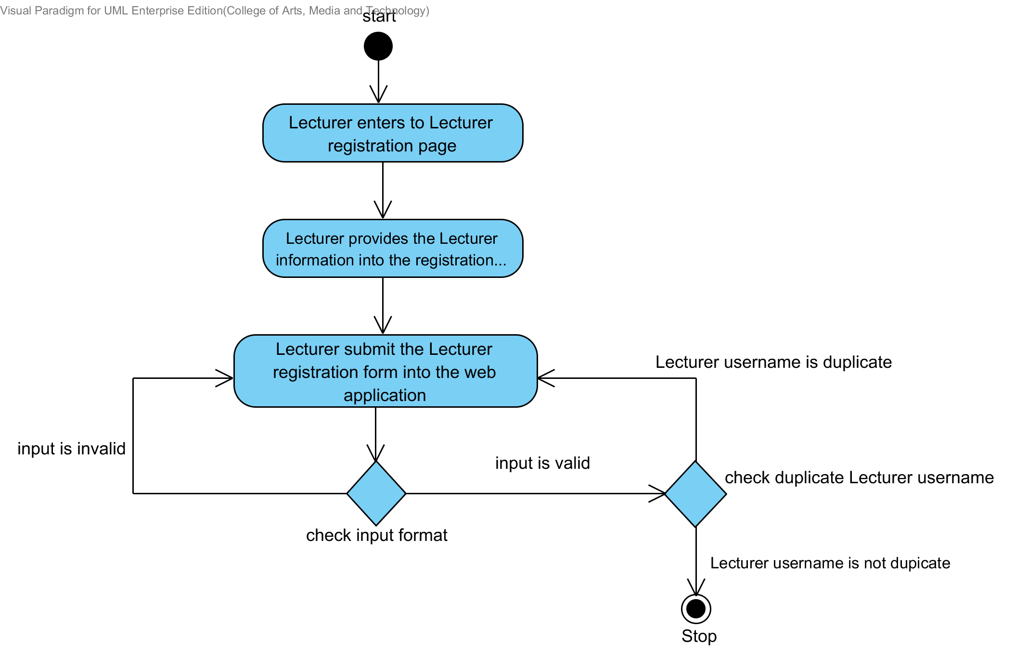

**System Requirement Specification of URS1.1**

**SRS 1-1.1:** The system shall redirect to Lecturer registration page on the web application.

**SRS 1-2-1:** The system shall redirect to Lecture main page on the web application.

**SRS 1-3.1:** The system shall provide Lecturer registration interface on the web application, including lecturer ID, lecturer username, lecturer password, lecturer name, lecturer faculty, lecturer department, lecturer email, and lecturer tel for Lecturer register to the system.

**SRS 1-4.1:** The system shall store the Lecturer personal information into the system after Lecturer submitted his/her register information from Lecturer registration interface on the web application.

**SRS 1-5.1:** The system shall display “Registration Successful” message when Lecturer registered the Lecturer account in Lecturer registration interface on the web application.

**SRS 1-6.1:** The system shall validate the format of the Lecturer personal information after the Lecturer submitted his/her information from Lecturer registration interface on the web application.

**SRS 1-7.1:** The system shall display “The Lecturer ID must be the number only” when the lecturer ID format is wrong.

**SRS 1-8.1:** The system shall display “The Lecturer’s username must be only 4-16 alphabet characters” when the lecturer username format is wrong.

**SRS 1-9.1:** The system shall display “The Lecturer’s password must be only 4-16 characters” when the lecturer password format is wrong.

**SRS 1-10.1**: The system shall display “The Lecturer’s name must be the combination of alphabet and space only” when the lecturer name format is wrong.

**SRS 1-111:** The system shall display “The Lecturer’s tel must be number only” when the lecturer tel format is wrong.

**SRS 1-12.1:** The system shall display “The Lecturer’s email must be the character and only one @ symbol” when the lecturer email format is wrong.

**SRS 1-13.1:** The system shall validate the duplication of the lecturer username after Lecturer submitted his/her information from Lecturer registration interface on the web application.

**SRS 1-14.1:** The system shall display “Existing Lecturer’s username, please using different Lecturer’s username” when the lecturer username duplicates exist lecturer username.

## **4.2 Student can register to the system. (UC 2.1)**

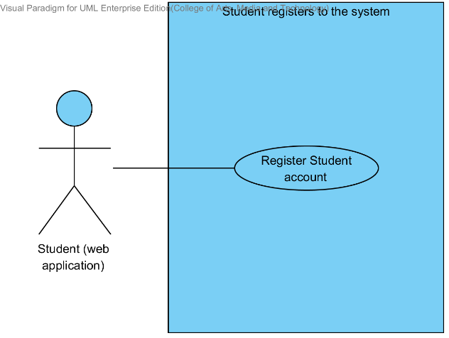

|  |  |  |  |  |
| --- | --- | --- | --- | --- |
| **Use Case ID:** | UC 2.1 | | | |
| **Use Case Name:** | Student registers to the system | | | |
| **Created By:** | Mr.Tanadol Parn-ong | | **Last Updated By:** | Mr.Tanadol Parn-ong |
| **Date Created:** | 10/05/2014 | | **Last Revision Date:** | 10/05/2014 |
| **Actors:** | | Student | | |
| **Description:** | | This use case is provided for Student request to register account to the system on the web application. | | |
| **Trigger:** | | Student enters to Student registration page. | | |
| **Preconditions:** | | N/A | | |
| **Post conditions:** | | Student sees “Registration Successful” message on the web application. | | |
| **Normal Flow:** | | 1. Student enters to Student registration page. 2. The system redirects to Student registration page on the web application. 3. The system provides Student registration interface on the mobile application, including student ID, student username, student password, student name, student address, student faculty, student department, student email, and student tel for Student register to the system. 4. Student provides the Student information into the registration page. 5. Student submits the Student registration form into the web application. 6. The system validates the format of the Student personal information. 7. The system validates the duplication of the lecturer username. 8. The system stores the Student personal information into the system. 9. The system displays “Registration Successful” message on the web application. 10. The system redirects to Student main page on the web application. | | |
| **Alternative Flows:** | | 6A. when the student ID format is wrong. The system provides the error message as followed:  1. The system displays “The Student ID must be the number only” on the web application.  2. Use Case resumes on step 5 of normal flow.  6B. when the student username format is wrong. The system provide the error message as followed:  1. The system displays “The Student’s username must be only 4-16 alphabet characters” on the web application.  2. Use Case resumes on step 4 of normal flow.  6C. when the student password format is wrong. The system provides the error message as followed:  1. The system displays “The Student’s password must be only 4-16 characters” on the web application.  2. Use Case resumes on step 4 of normal flow.  6D. when the student name format is wrong. The system provides the error message as followed:  1. The system displays “The Student’s name must be the combination of alphabet and space only” on the web application.  2. Use Case resumes on step 4 of normal flow.  6E. when the student tel format is wrong. The system provides the error message as followed:  1. The system displays “The Student’s tel must be number only” on the web application.  2. Use Case resumes on step 4 of normal flow.  6F. when the student email format is wrong. The system provides the error message as followed:  1. The system displays “The Student’s email must be the character and only one @ symbol” on the web application.  2. Use Case resumes on step 4 of normal flow.  7A. when the student username is duplicate with exist student username in the system. The system provides the error message as followed: “Existing Student’s username, please using different Student’s username” on the web application. | | |
| **Exceptions:** | | N/A | | |
| **Includes:** | | N/A | | |
| **Frequency of Use:** | | Only at the first time when user begins to use this application. | | |
| **Assumptions:** | | N/A | | |
| **Notes and Issues:** | | N/A | | |

**URS 2.1 Student can register to the system**

Student must register into the web application, in order to using the other features as Student. Student have to provide student ID, student username, student password, student name, student address, student faculty, student department, student email, and student tel into the system. After, the registration has been completed. The web application will redirect to the Student main page.

**Actor:** The users

**Prerequisite:** -

**Input:**

|  |  |  |  |
| --- | --- | --- | --- |
| Name | Description | Example | Remarks |
| student ID | Only number is allowed. | 542115099 |  |
| student username | Only Alphabet is allowed, within the range of 4-16 Characters | “jenny” |  |
| student password | Can be any character within the range of 4-16 characters. | “12345” |  |
| student name | Only The combination of alphabet and space is allowed. | “Jenny Stark” |  |
| student faculty | Can be any character is allowed. | College of Arts media and technology, Chiang mai University |  |
| student department | Can be any character is allowed. | Software engineer |  |
| student address | Can be any character. | Women dorm 4, Chiang mai university, Chiang mai, Thailand, 50000 |  |
| student email | The combination of character and only one @ symbol is allowed. | jenny999@gmail.com |  |
| student tel | Only number is allowed. | 0823207777 |  |

**Flow of Execution:**

1. Student enters to Student registration page.
2. Student provides the Student information into the registration page.
3. Student submits the Student registration form into the web application.

**Alternative Flow**

3A. if Student input data in the wrong format, the system should provide the error message as followed:

* + The wrong student ID format: The error message is “The Student ID must be number only”
  + The wrong username format: The error message is “The Student’s username must be only 4-16 alphabet characters”
  + The wrong password format: The error message is “The Student’s password must be only 4-16 characters”
  + The wrong name format: The error message is “The Student’s name must be the combination of alphabet and space only”
  + The wrong Tel format: The error message is “The Student’s tel must be number only”
  + The wrong student email format: The error message is “The Student’s email must be the character and only one @ symbol”

3B. if Student submitted the data, but there is the existing username in the system. The system won’t allow the user the register with that Username. The system will display the error message “Existing Student’s username, please using different Student’s username” to the user.

**AC-02.1 Student can register to the system**

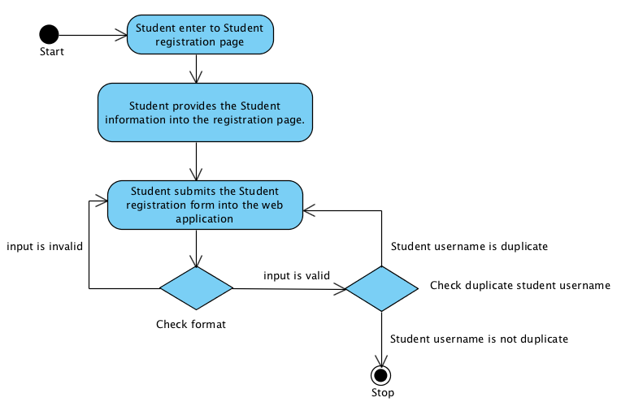

**System Requirement Specification of URS 2.1**

**SRS 2-1.1:** The system shall redirect to Student registration page on the web application.

**SRS 2-2.1:** The system shall redirect to Student main page on the web application.

**SRS 2-3.1:** The system shall provide Student registration interface on the web application, including student ID, student username, student password, student name, student address, student faculty, student department, student email, and student tel for Student register to the system.

**SRS 2-4.1:** The system shall store the Student personal information into the system after Student submitted his/her register information from Student registration interface on the web application.

**SRS 2-5.1:** The system shall display “Registration Successful” message when Student registered the Student account in Student registration interface on the web application.

**SRS 2-6.1:** The system shall validate the format of the Student information after the Student submitted his/her information from Student registration interface on the web application.

**SRS 2-7.1:** The system shall display “The Student ID must be the number only” when the student ID format is wrong.

**SRS 2-8.1:** The system shall display “The Student’s username must be only 4-16 alphabet characters” when the student username format is wrong.

**SRS 2-9.1:** The system shall display “The Student’s password must be only 4-16 characters” when the student password format is wrong.

**SRS 2-10.1:** The system shall display “The Student’s name must be the combination of alphabet and space only” when the student name format is wrong.

**SRS 2-11.1:** The system shall display “The Student’s tel must be number only” when the student tel format is wrong.

**SRS 2-12.1:** The system shall display “The Student’s email must be the character and only one @ symbol” when the student email format is wrong.

**SRS 2-13.1:** The system shall validate the duplication of the student username after Student submitted his/her information from Student registration interface on the web application.

**SRS 2-14.1:** The system shall display “Existing Student’s username, please using different Student’s username” when the student username duplicates exist student username.

## **4.3 Administrator can approve Lecturer or Student account. (UC 3.1)**

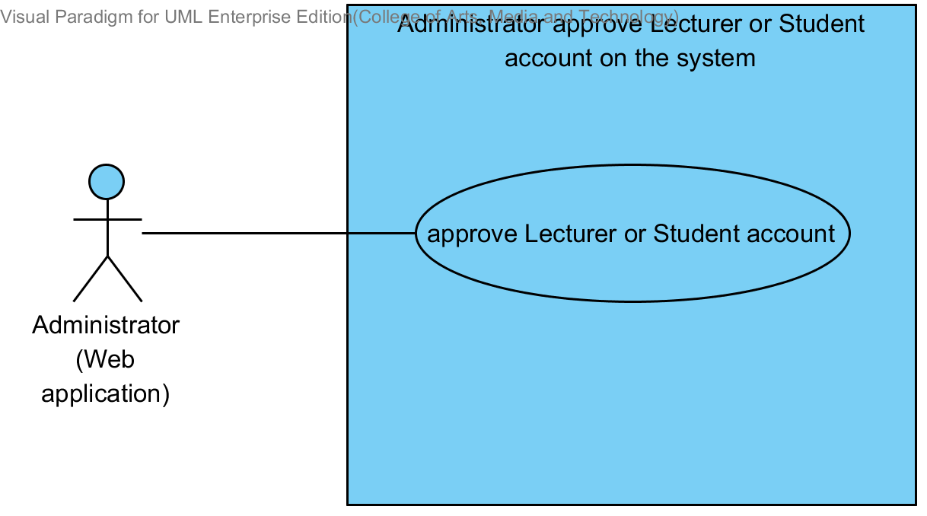

|  |  |  |  |  |
| --- | --- | --- | --- | --- |
| **Use Case ID:** | UC 3.1 | | | |
| **Use Case Name:** | Administrator approve account | | | |
| **Created By:** | Mr. Tanadol Parn-ong | | **Last Updated By:** | Mr. Tanadol Parn-ong |
| **Date Created:** | 10/05/2014 | | **Last Revision Date:** | 10/05/2014 |
| **Actors:** | | Administrator | | |
| **Description:** | | This use case is provided for Administrator approve account to the system on the web application. | | |
| **Trigger:** | | Administrator enters to manage account main page. | | |
| **Preconditions:** | | Lecturer and Student must register into system. | | |
| **Post conditions:** | | The system display “Approbation Successful” message. | | |
| **Normal Flow:** | | 1. Administrator enters the Administrator main page. 2. The system redirects to Administrator main page interface. 3. Administrator enters to manage account main page. 4. The system redirects to manage account main page interface. 5. Administrator enters the Lecturer account approve page. 6. The system redirects to the Lecturer account approve page interface. 7. Administrator click approve Lecturer account from Lecturer account approve page. 8. The system will update the data in database. 9. The system display “Approve Successful” message. | | |
| **Alternative Flows:** | | 5A If Administrator need to approve Student account.   1. Administrator enters the Student account approve page. 2. The system display to the Student account approve page interface. 3. Administrator click approve Student account from Student account approve page. 4. Use Case resumes on step 8 of normal flow.   7A If Administrator doesn’t want to approve he should click “Not Approve” | | |
| **Exceptions:** | | N/A | | |
| **Includes:** | | N/A | | |
| **Frequency of Use:** | | Depend on the user registration | | |
| **Assumptions:** | | N/A | | |
| **Notes and Issues:** | | N/A | | |

**URS3.1 Administrator can approve Lecturer or Student account.**

The Administrator must approve Lecturer or Student account that fully qualification.

**Actor:** The Administrator

**Input: None**

**Prerequisite:** -

**Flow of Execution:**

1. Administrator enters the Administrator main page.
2. Administrator enters to manage account main page.
3. Administrator enters the Lecturer account approve page.
4. Administrator click approve Lecturer account from Lecturer account approve page.

**Alternative Flow**

4A. If Administrator need to approve Student account:

1. Administrator click approve Lecturer account from Lecturer account approve page.

**AC-03.1 Administrator can approve Lecturer or Student account.**

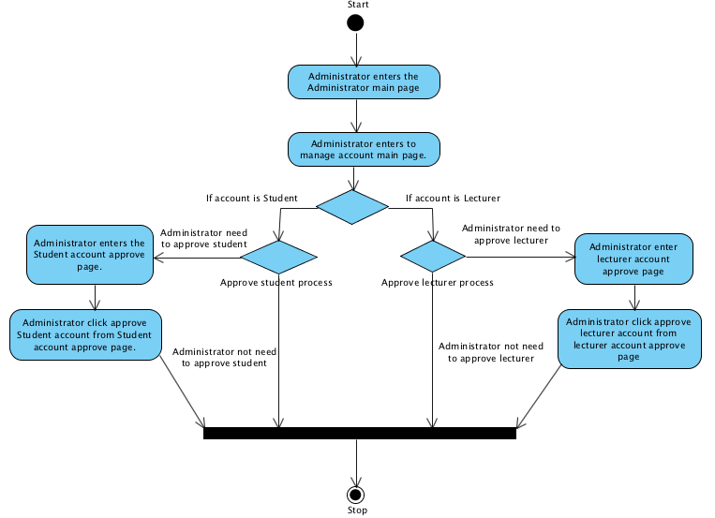

**System Requirement Specification of URS3.1**

**SRS 3-1.1:** The system shall redirect to Administrator main page interface.

**SRS 3-2.1:** The system shall redirect to manage account main page interface.

**SRS 3-3.1**: The system shall redirect to the Lecturer account approve page interface

**SRS 3-4.1**: The system shall validate the user status form Administrator.

**SRS 3-5.1:** The system will update the data in database.

**SRS 3-6.1:** The system shall display “Approve Successful” message.

**SRS 3-7.1:** The system shall redirect to the Lecturer account approve page interface.

## **4.4 Lecturer can edit personal information. (UC 4.1)**

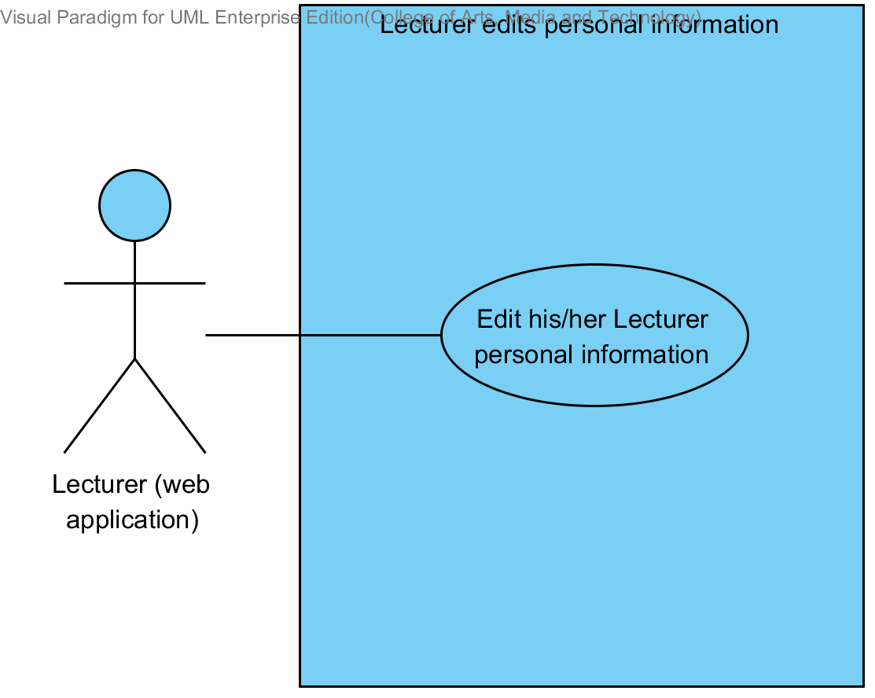

|  |  |  |  |  |
| --- | --- | --- | --- | --- |
| **Use Case ID:** | UC 4.1 | | | |
| **Use Case Name:** | Lecturer edits personal information. | | | |
| **Created By:** | Mr.Tanadol Parn-ong | | **Last Updated By:** | Mr.Tanadol Parn-ong |
| **Date Created:** | 10/05/2014 | | **Last Revision Date:** | 10/05/2014 |
| **Actors:** | | Lecturer | | |
| **Description:** | | This use case is provided for Lecturer edits his/her personal information on the web application. | | |
| **Trigger:** | | Lecturer enters to Lecturer personal information page. | | |
| **Preconditions:** | | Lecturer profile should be available in the system for editing. | | |
| **Post conditions:** | | Lecturer sees “Editing Information Successful” message on the web application. | | |
| **Normal Flow:** | | 1. Lecturer enters to Lecturer personal information page. 2. The system redirects to Lecturer personal information interface on the web application. 3. The system provides Lecturer personal information interface on the web application, including lecturer password, lecturer name, lecturer faculty, lecturer department, lecturer email, and lecturer tel. 4. Lecturer provides information that want to edit. 5. Lecturer provides confirm password for editing. 6. Lecturer submits edition personal information on the web application. 7. The system validates the format of the Lecture personal information. 8. The system validates the similarity of password and confirm password 9. The system updates Lecturer personal information into the system. 10. The system displays “Editing Information Successful” message on the web application. | | |
| **Alternative Flows:** | | 7A. when the lecturer password format is wrong. The system provides the error message as followed:  1. The system displays “The Lecturer’s password must be only 4-16 characters” on the web application.  2. Use Case resumes on step 5 of normal flow.  7B. when the lecturer name format is wrong. The system provides the error message as followed:  1. The system displays “The Lecturer’s name must be the combination of alphabet and space only” on the web application.  2. Use Case resumes on step 6 of normal flow.  7C. when the lecturer tel format is wrong. The system provides the error message as followed:  1. The system displays “The Lecturer’s tel must be number only” on the web application.  2. Use Case resumes on step 6 of normal flow.  7D. when the lecturer email format is wrong. The system provides the error message as followed:  1. The system displays “The Lecturer’s email must be the character and only one @ symbol” on the web application.  2. Use Case resumes on step 6 of normal flow.  8A. when the lecturer password and confirm password is not matched. The system provides the error message as followed:  1. The system displays “Password and confirm password is not matched” on the web application.  2. Use Case resumes on step 6 of normal flow. | | |
| **Exceptions:** | | N/A | | |
| **Includes:** | | N/A | | |
| **Frequency of Use:** | | Often | | |
| **Assumptions:** | | N/A | | |
| **Notes and Issues:** | | N/A | | |

**URS 4.1 Lecturer can edit his/her personal information.**

Lecturer can edit his/her personal information into the web application which consist lecturer ID, lecturer password, lecturer name, lecturer faculty, lecturer department, lecturer email, and lecturer tel.

**Actor:** Lecturer

**Prerequisite:** Lecturer must have logged**.**

**Input:**

|  |  |  |  |
| --- | --- | --- | --- |
| Name | Description | Example | Remarks |
| lecturer password | Can be any character within the range of 4-16 characters. | “123456” |  |
| lecturer name | Only The combination of alphabet and space is allowed. | “Tony Stark” |  |
| lecturer faculty | Can be any character is allowed. | College of Arts media and technology, Chiang mai University |  |
| lecturer department | Can be any character is allowed. | Software engineering |  |
| lecturer email | The combination of character and only one @ symbol is allowed. | tony999@gmail.com |  |
| lecturer tel | Only number is allowed. | 0832109999 |  |

**Flow of Execution:**

1. Lecturer enters to Lecturer personal information page.
2. Lecturer provides information that want to edit.
3. Lecturer provides confirm password for editing.
4. Lecturer submits edition personal information on the web application.

**AC-04.1 Lecturer can edit his/her personal information.**

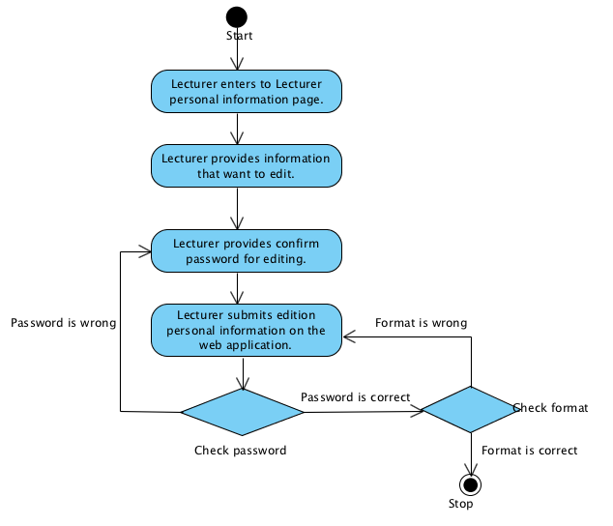

**System Requirement Specification of URS 4.1**

**SRS 4-1.1:** The system shall redirect to Lecturer personal information interface on the web application.

**SRS 4-2.1:** The system shall provide Lecturer personal information interface on the web application, including lecturer password, lecturer name, lecturer faculty, lecturer department, lecturer email, and lecturer tel for Lecturer edits his/her personal information into the system.

**SRS 4-3.1:** The system shall update Lecturer personal information into the system after Lecturer submits to edit his/her personal information from Lecturer personal information interface on the web application.

**SRS 4-4.1:** The system shall display “Editing Information Successful” message when Lecturer edited the Lecturer personal information in Lecturer personal information interface on the web application.

**SRS 4-5.1:** The system shall validate the format of the Lecture personal information after Lecturer submitted his/her personal information from Lecturer personal information interface on the web application.

**SRS 4-6.1:** The system shall display “The Lecturer’s password must be only 4-16 characters” when the lecturer password format is wrong.

**SRS 4-7.1:** The system shall display “The Lecturer’s name must be the combination of alphabet and space only” when the lecturer name format is wrong.

**SRS 4-8.1:** The system shall display “The Lecturer’s tel must be number only” when the lecturer tel format is wrong.

**SRS 4-9.1:** The system shall display “The Lecturer’s email must be the character and only one @ symbol” when the lecturer email format is wrong.

**SRS 4-10.1:** The system shall validate the similarity of password and confirm password after Lecturer submitted his/her personal information from Lecturer personal information interface in the web application.

**SRS 4-11.1:** The system shall display “Password and confirm password is not matched” when password and confirm password is not matched.

## **4.5 Student can edit personal information. (UC 5.1)**

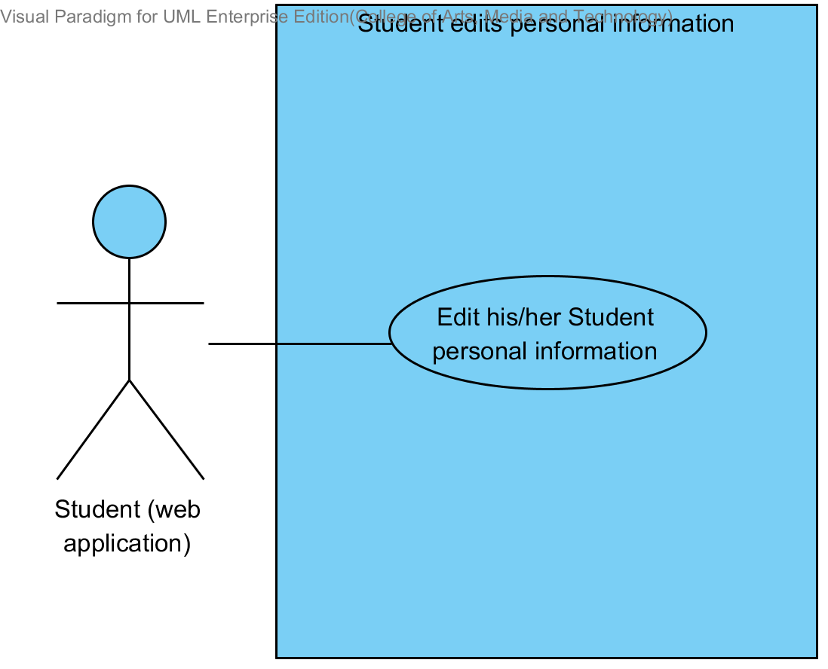

|  |  |  |  |  |
| --- | --- | --- | --- | --- |
| **Use Case ID:** | UC 5.1 | | | |
| **Use Case Name:** | Student edits personal information. | | | |
| **Created By:** | Mr.Tanadol Parn-ong | | **Last Updated By:** | Mr.Tanadol Parn-ong |
| **Date Created:** | 10/05/2014 | | **Last Revision Date:** | 10/05/2014 |
| **Actors:** | | Student | | |
| **Description:** | | This use case is provided for Student edits his/her personal information on the web application. | | |
| **Trigger:** | | Student enters to Student personal information page. | | |
| **Preconditions:** | | Student must logged in to the system. | | |
| **Post conditions:** | | Student sees “Editing Information Successful” message on the web application. | | |
| **Normal Flow:** | | 1. Student enters to Student personal information page. 2. The system redirects to Student personal information interface on the web application. 3. The system provides Student personal information interface on the web application, including student password, student name, student faculty, student department, student address, student email, and student tel. 4. Student provides information that want to edit. 5. Student provides confirm password for editing. 6. Student submits edition personal information on the web application. 7. The system validates the format of the Student personal information. 8. The system validates the similarity of password and confirm password 9. The system updates Student personal information into the system. 10. The system displays “Editing Information Successful” message on the web application. | | |
| **Alternative Flows:** | | 7A. when the student password format is wrong. The system provides the error message as followed:  1. The system displays “The Student’s password must be only 4-16 characters” on the web application.  2. Use Case resumes on step 5 of normal flow.  7B. when the student name format is wrong. The system provides the error message as followed:  1. The system displays “The Student’s name must be the combination of alphabet and space only” on the web application.  2. Use Case resumes on step 6 of normal flow.  7C. when the student tel format is wrong. The system provides the error message as followed:  1. The system displays “The Student’s tel must be number only” on the web application.  2. Use Case resumes on step 6 of normal flow.  7D. when the student email format is wrong. The system provides the error message as followed:  1. The system displays “The Student’s email must be the character and only one @ symbol” on the web application.  2. Use Case resumes on step 6 of normal flow.  8A. when the student password and confirm password is not matched. The system provides the error message as followed:  1. The system displays “Password and confirm password is not matched” on the web application.  2. Use Case resumes on step 6 of normal flow. | | |
| **Exceptions:** | | N/A | | |
| **Includes:** | | N/A | | |
| **Frequency of Use:** | | Often | | |
| **Assumptions:** | | N/A | | |
| **Notes and Issues:** | | N/A | | |

**URS 5.1 Student can edit his/her personal information.**

Student can edit his/her personal information into the web application which consist student ID, student password, student name, student address, student faculty, student department, student email, and student tel.

**Actor:** Student

**Prerequisite:** Student must have logged**.**

**Input:**

|  |  |  |  |
| --- | --- | --- | --- |
| Name | Description | Example | Remarks |
| student ID | Only number is allowed. | 542115099 |  |
| student password | Can be any character within the range of 4-16 characters. | “123456” |  |
| student name | Only The combination of alphabet and space is allowed. | “Jenny Stark” |  |
| student faculty | Can be any character is allowed. | College of Arts media and technology, Chiang mai University |  |
| student department | Can be any character is allowed. | Software engineering |  |
| student address | Can be any character. | Women dorm 4, Chiang mai university, Chiang mai, Thailand, 50000 |  |
| student email | The combination of character and only one @ symbol is allowed. | jenny999@gmail.com |  |
| student tel | Only number is allowed. | 0823207777 |  |

**Flow of Execution:**

1. Student enters to Student personal information page.
2. Student provides information that want to edit.
3. Student provides confirm password for editing.
4. Student submits edition personal information form.

**Alternative Flow:**

4A. if Student input data in the wrong format, the system should provide the error message as followed:

* + The wrong password format: The error message is “The Student’s password must be only 4-16 characters”
  + The wrong name format: The error message is “The Student’s name must be the combination of alphabet and space only”
  + The wrong Tel format: The error message is “The Student’s tel must be number only”
  + The wrong student email format: The error message is “The Student’s email must be the character and only one @ symbol”

4B. if Student submitted the data, but password and confirm password is not matched. The system will display the error message “Password and confirm password is not matched” to Student.

**AC-05 Student can edit his/her personal information.**

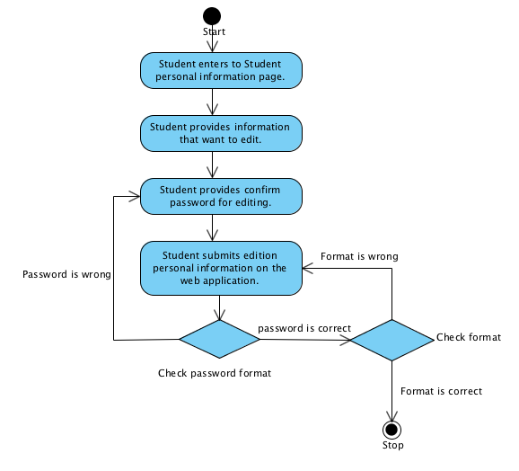

**System Requirement Specification of URS 5.1**

**SRS 5-1.1:** The system shall redirect to Student personal information interface on the web application.

**SRS 5-2.1:** The system shall provide Student personal information interface on the web application, including student password, student name, student faculty, student department, student address, student email, and student tel for Student edits his/her personal information into the system.

**SRS 5-3.1:** The system shall update Student personal information into the system after Student submits to edit his/her personal information from Student personal information interface on the web application.

**SRS 5-4.1:** The system shall display “Editing Information Successful” message when Student edited the Student personal information in Student personal information interface on the web application.

**SRS 5-5.1:** The system shall validate the format of the Student personal information after Student submitted his/her personal information from Student personal information interface on the web application.

**SRS 5-6.1:** The system shall display “The Student’s password must be only 4-16 characters” when the student password format is wrong.

**SRS 5-7.1:** The system shall display “The Student’s name must be the combination of alphabet and space only” when the student name format is wrong.

**SRS 5-8.1:** The system shall display “The Student’s tel must be number only” when the student tel format is wrong.

**SRS 5-9.1:** The system shall display “The Student’s email must be the character and only one @ symbol” when the student email format is wrong.

**SRS 5-10.1:** The system shall validate the similarity of password and confirm password after Student submitted his/her personal information from Student personal information interface in the web application.

**SRS 5-11.1:** The system shall display “Password and confirm password is not matched” when password and confirm password is not matched.

## **User can log in to the system. (UC 6.1)**

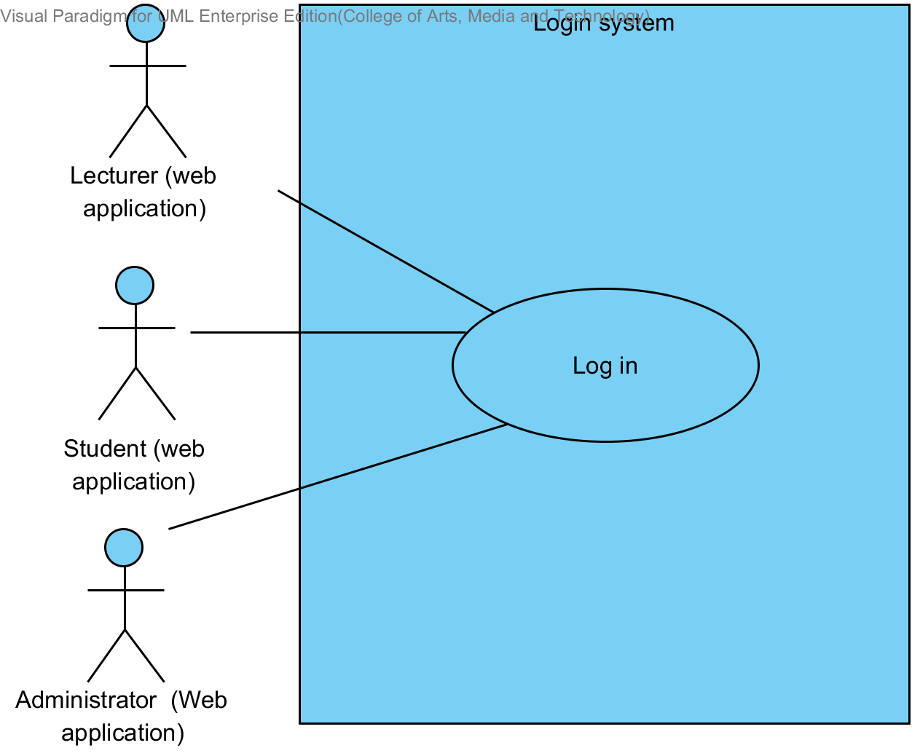

|  |  |  |  |  |
| --- | --- | --- | --- | --- |
| **Use Case ID:** | UC 6.1 | | | |
| **Use Case Name:** | Login to the system. | | | |
| **Created By:** | Mr.Tanadol Parn-ong | | **Last Updated By:** | Mr.Tanadol Parn-ong |
| **Date Created:** | 10/05/2014 | | **Last Revision Date:** | 10/05/2014 |
| **Actors:** | | User consists Lecturer, Student, and Administrator | | |
| **Description:** | | This use case is provided for User log in to the system on the web application. | | |
| **Trigger:** | | User enters to Login page. | | |
| **Preconditions:** | | User is registered into the system and has his/her account. | | |
| **Post conditions:** | | The system redirects to Lecture or Student or Administrator main page on the web application. | | |
| **Normal Flow:** | | 1. User enters to Login page. 2. The system redirects to Login page on the web application. 3. The system provides Login interface on the web application, including username and password 4. User provides login information into the web application. 5. User submit login form into the web application. 6. The system fetches login information of User from the system to validate the correctness of login information in Login interface on the web application. 7. The system redirects to Lecture main page on the web application. | | |
| **Alternative Flows:** | | 6A. when the username and password is wrong. The system provides the error message as followed:  1. The system displays “Invalid Username and/or Password” on the mobile application.  2. Use Case resumes on step 4 of normal flow.  7A. if Student log in to the system.  1. The system redirects to Student main page on the web application.  7B if Administrator log in to the system  1. The system displays to Administrator main page interface. | | |
| **Exceptions:** | | N/A | | |
| **Includes:** | | N/A | | |
| **Frequency of Use:** | | Often | | |
| **Assumptions:** | | N/A | | |
| **Notes and Issues:** | | N/A | | |

**URS 6.1 User can login to the system.**

User can login to the system by providing username and password into the web application.

**Actor:** Lecturer, Student, Administrator

**Prerequisite:** -

**Input:**

|  |  |  |  |
| --- | --- | --- | --- |
| Name | Description | Example | Remarks |
| lecturer username | Only Alphabet is allowed, within the range of 4-16 Characters | “tony” |  |
| lecturer password | Can be any character within the range of 4-16 characters. | “12345” |  |

**Flow of Execution:**

1. User enters to Login page.
2. User provides login information into the weeb application.
3. User submit login form into the mobile application.

**Alternative Flow**

3A. if the username and password are not matched, the system will display the error message “Invalid Username and/or Password” to the user.

**AC-06.1 User can login to the system.**

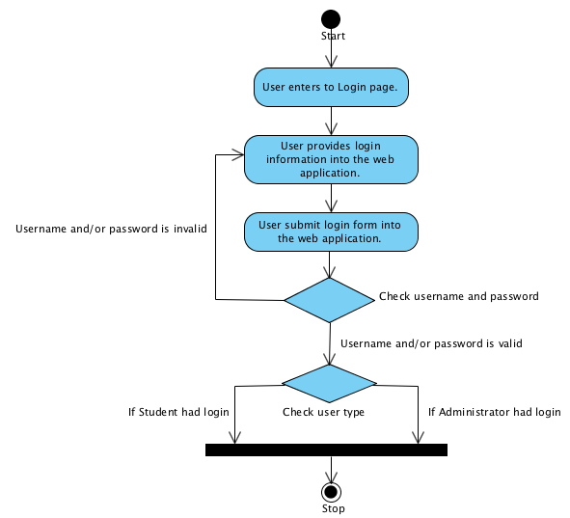

**System Requirement Specification of URS 6.1**

**SRS 1-2.1:** The system shall redirect to Lecture main page on the web application.

**SRS 2-2.1:** The system shall redirect to Student main page on the web application.

**SRS3-1.1:** The system displays to Administrator main page interface.

**SRS 6-1.1:** The system shall redirect to Login page on the web application.

**SRS 6-2.1:** The system shall provide Login interface on the web application, including username and password for Lecturer/Student login his/her account into the system.

**SRS 6-3.1:** The system shall fetch login information of Lecturer/Student from the system to validate the correctness of login information in Login interface on the web application.

**SRS 6-4.1:** The system shall display “Invalid Username and/or Password” when username and password are wrong to Lecturer/Student.

## **User can log out to the system. (UC 7.1)**

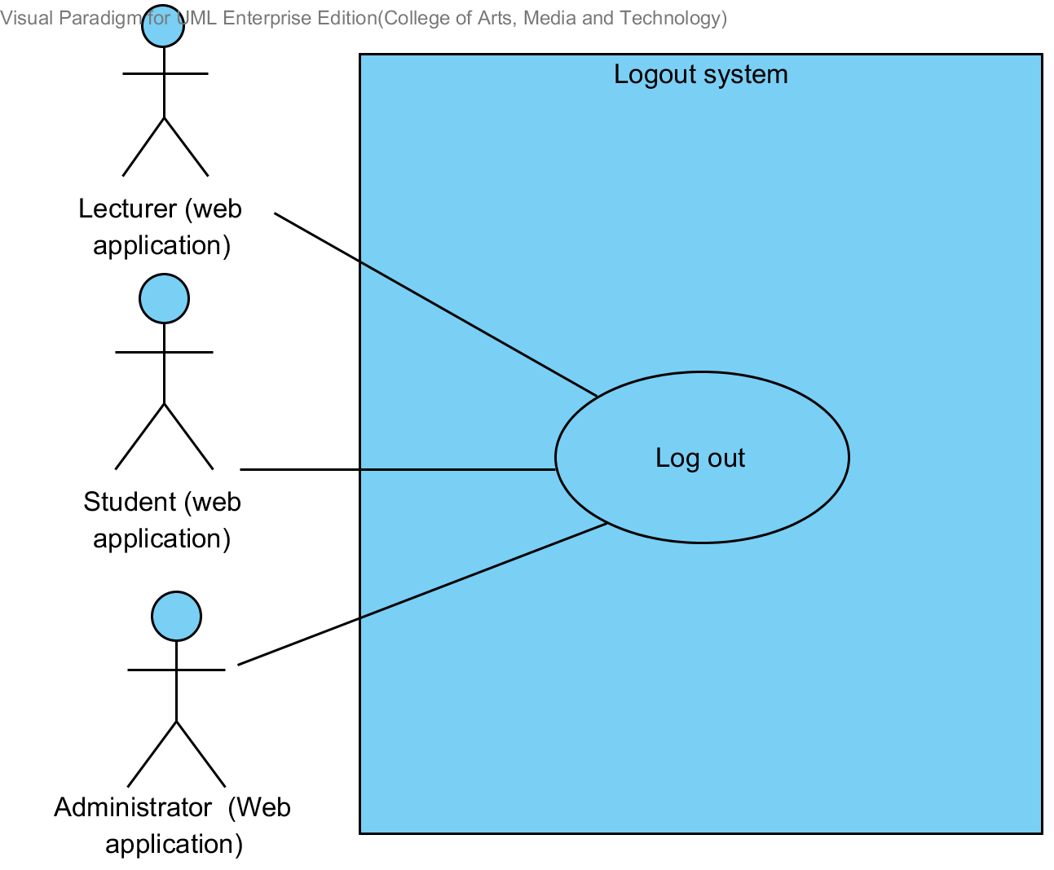

|  |  |  |  |  |
| --- | --- | --- | --- | --- |
| **Use Case ID:** | UC 7.1 | | | |
| **Use Case Name:** | Logout system. | | | |
| **Created By:** | Mr.Tanadol Parn-ong | | **Last Updated By:** | Mr.Tanadol Parn-ong |
| **Date Created:** | 10/05/2014 | | **Last Revision Date:** | 10/05/2014 |
| **Actors:** | | User consists Lecturer, Student, and Administrator | | |
| **Description:** | | This use case is provided for User log out the system on the mobile application. | | |
| **Trigger:** | | User submits log out form. | | |
| **Preconditions:** | | User must logged in to the system. | | |
| **Post conditions:** | | The system redirects to Login page on the web application. | | |
| **Normal Flow:** | | 1. The system provides Log out form in all page on the web application. 2. User submits log out form on the web application. 3. The system redirects to Login page on the web application. | | |
| **Alternative Flows:** | | N/A | | |
| **Exceptions:** | | N/A | | |
| **Includes:** | | N/A | | |
| **Frequency of Use:** | | Often | | |
| **Assumptions:** | | N/A | | |
| **Notes and Issues:** | | N/A | | |

**URS 7.1 Lecturer/Student can log out from the system.**

User can log out from the system on the web application.

**Actor:** Lecturer, Student, Administrator

**Prerequisite:** User must have logged**.**

**Input: None**

**Flow of Execution:**

1. User submits log out form on the web application.

**Alternative Flow**

-

**AC-07.1 Lecturer/Student can log out from the system.**

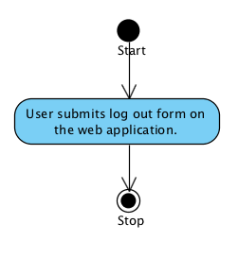

**System Requirement Specification of URS 7.1**

**SRS 6-1.1:** The system shall redirect to Login page on the web application.

**SRS 7-1.1:** The system provides Log out form in all page on the web application.

## **Administrator can create a semester. (UC 8.1)**

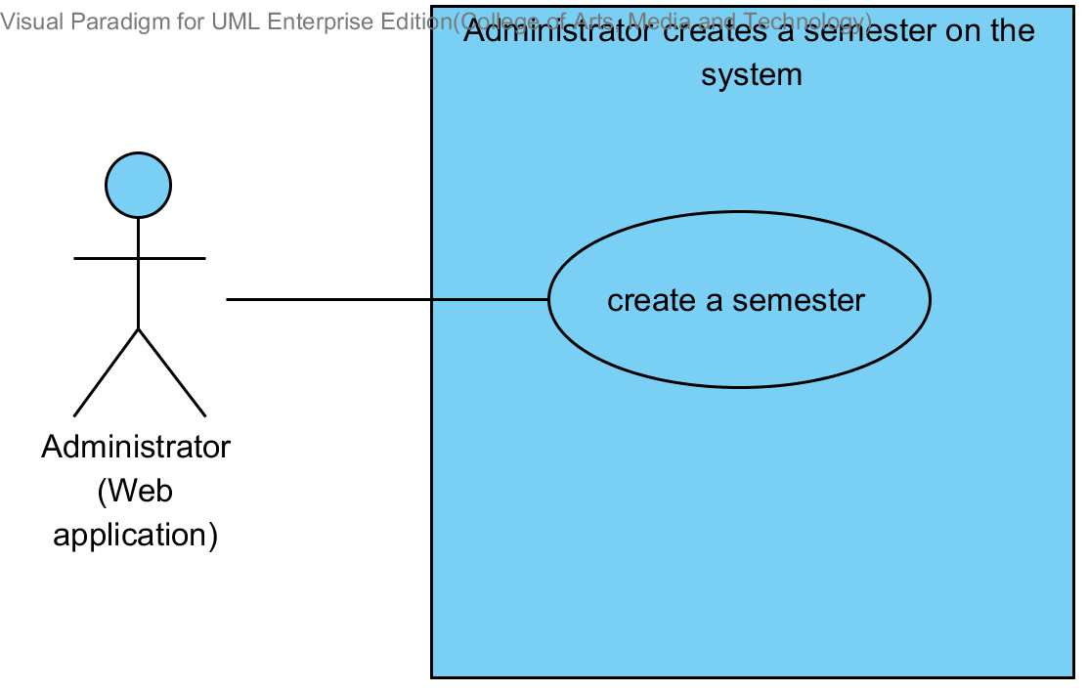

|  |  |  |  |  |
| --- | --- | --- | --- | --- |
| **Use Case ID:** | UC 8.1 | | | |
| **Use Case Name:** | Administrator can create a semester. | | | |
| **Created By:** | Mr.Tanadol Parn-ong | | **Last Updated By:** | Mr.Tanadol Parn-ong |
| **Date Created:** | 10/05/2014 | | **Last Revision Date:** | 10/05/2014 |
| **Actors:** | | Administrator | | |
| **Description:** | | This use case is provided for Administrator to create a semester. | | |
| **Trigger:** | | Administrator enters the Semester main page. | | |
| **Preconditions:** | | - | | |
| **Post conditions:** | | The system display “Addition Semester Successful” message. | | |
| **Normal Flow:** | | 1. Administrator enters the Semester main page. 2. The system displays the Semester main page interface. 3. Administrator provides semester academic year information into the web application. 4. Administrator submits semester academic year information. 5. The system must validate semester academic year information from Administrator. 6. The system display “Add Semester Successful” message. | | |
| **Alternative Flows:** | | 5A. If Administrator input semester academic year in the wrong format, the system should provide the error message as followed:   * 1. The wrong semester academic year format: The error message is “Semester academic year must be S/YYYY form, where S is a semester and YYYY is an academic year”   2. Use Case resumes on step 3 of normal flow.   5B. If Administrator input semester academic year that already exists, the system should provide the error message as followed:   * 1. The semester and academic year that already exist format: The error message is” The semester and academic year that already exist please type the another semester or academic year”   2. Use Case resumes on step 3 of normal flow. | | |
| **Exceptions:** | | N/A | | |
| **Includes:** | | N/A | | |
| **Frequency of Use:** | | Often | | |
| **Assumptions:** | | N/A | | |
| **Notes and Issues:** | | N/A | | |

**URS8.1. Administrator can create a semester.**

Administrator can create a semester by providing semester academic year information.

**Actor:** Administrator

**Prerequisite:** Administrator must have logged**.**

**Input:**

|  |  |  |  |
| --- | --- | --- | --- |
| Name | Description | Example | Remarks |
| Semester academic year | Form of semester academic year “S/YYYY”  - S is a semester  - Y is an academic year | “1/2557” |  |

**Flow of Execution:**

1. Administrator enters the Semester main page.
2. Administrator provides semester academic year information into the web application.
3. Administrator submits semester academic year information.

**Alternative Flow**

5A. if Administrator input semester academic year in the wrong format, the system should provide the error message as followed:

* + The wrong semester academic year format: The error message is “Semester academic year must be S/YYYY form, where S is a semester and YYYY is an academic year”

5B. if Administrator input semester academic year that already exists, the system should provide the error message as followed:

* + The semester and academic year that already exist format: The error message is” The semester and academic year that already exist please type the another semester or academic year”

**AC-08.1 Administrator can create a semester.**

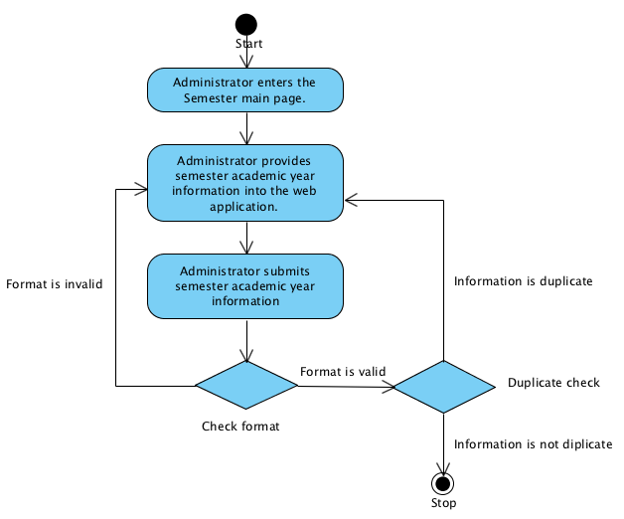

**System Requirement Specification of URS8.1**

**SRS 8-1.1:** The system shall redirect to the Semester main page interface.

**SRS 8-2.1:** The system must validate semester academic year information from Administrator.

**SRS 8-3.1:** The system shall store the data in the database table.

**SRS 8-4.1:** The system shall display “Add Semester Successful” message.

**SRS 8-5.1:** The system shall display “Semester academic year must be S/YYYY form, where S is a semester and YYYY is an academic year” message.

**SRS 8-6.1:** The system shall display “The semester and academic year that already exist please type another semester or academic year” message.

## **4.9 Administrator can edit a semester. (UC 9.1)**

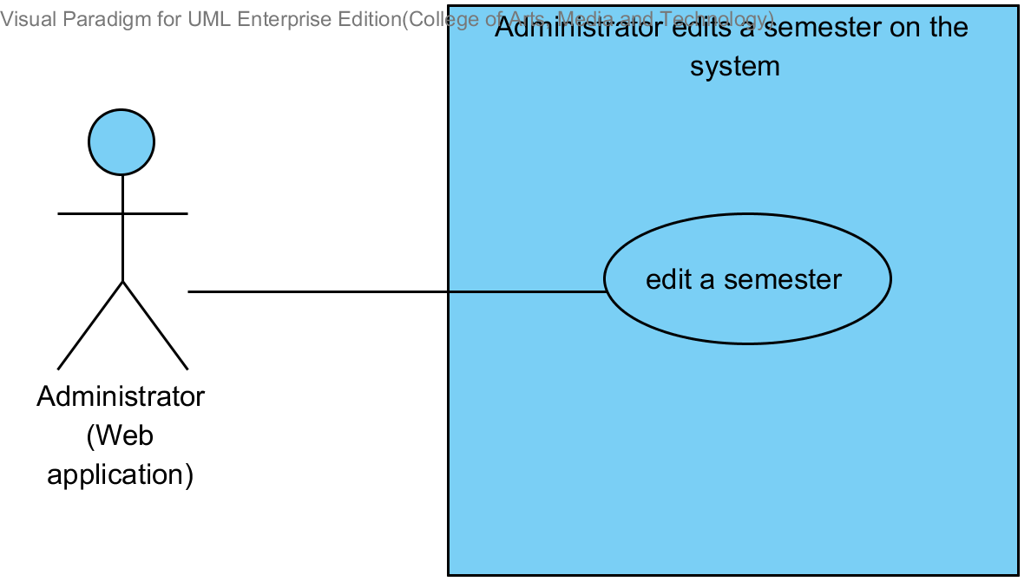

|  |  |  |  |  |
| --- | --- | --- | --- | --- |
| **Use Case ID:** | UC 9.1 | | | |
| **Use Case Name:** | Administrator can edit a semester | | | |
| **Created By:** | Mr.Tanadol Parn-ong | | **Last Updated By:** | Mr.Tanadol Parn-ong |
| **Date Created:** | 10/05/2014 | | **Last Revision Date:** | 10/05/2014 |
| **Actors:** | | Administrator | | |
| **Description:** | | This use case is provided for Administrator edit a semester on the web application. | | |
| **Trigger:** | | Administrator enters edition semester academic year form. | | |
| **Preconditions:** | | Semester information should be in the system. | | |
| **Post conditions:** | | The system display “Editing Semester Successful” message. | | |
| **Normal Flow:** | | 1. Administrator enters edition semester academic year form. 2. The system displays to the Edition semester page. 3. Administrator provides semester academic year information into the web application. 4. Administrator submits semester academic year into the web application. 5. The system must validate semester academic year information from Administrator. 6. The system display “Editing Semester Successful” message. | | |
| **Alternative Flows:** | | 5A. If Administrator input semester academic year in the wrong format, the system should provide the error message as followed:   * 1. The wrong semester academic year format: The error message is “Semester academic year must be S/YYYY form, where S is a semester and YYYY is an academic year”   2. Use Case resumes on step 3 of normal flow. | | |
| **Exceptions:** | | N/A | | |
| **Includes:** | | N/A | | |
| **Frequency of Use:** | | Often | | |
| **Assumptions:** | | N/A | | |
| **Notes and Issues:** | | N/A | | |

**URS9.1. Administrator can edit a semester.**

Administrator can edit a semester by providing semester academic year information.

**Actor:** Administrator

**Prerequisite:** Administrator must have logged**.**

**Input:**

|  |  |  |  |
| --- | --- | --- | --- |
| Name | Description | Example | Remarks |
| Semester academic year | Form of semester academic year “S/YYYY”  - S is a semester  - Y is an academic year | “2/2557” |  |

**Flow of Execution:**

1. Administrator enters edition semester academic year form.
2. Administrator provides semester academic year information into the web application.
3. Administrator submits semester academic year into the web application.

**Alternative Flow**

3A. if Administrator input semester academic year in the wrong format, the system should provide the error message as followed:

* + The wrong semester academic year format: The error message is “Semester academic year must be S/YYYY form, where S is a semester and YYYY is an academic year”

**AC-09.1 Administrator can edit a semester.**

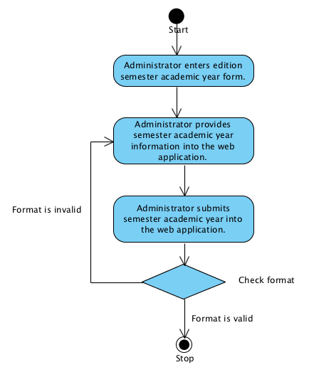

**System Requirement Specification of URS9.1**

**SRS 8-5.1:** The system shall display “Semester academic year must be S/YYYY form, where S is a semester and YYYY is an academic year” message.

**SRS 9-1.1:** The system shall redirect to the Edition semester page.

**SRS 9-2.1:** The system must validate semester academic year information from Administrator.

**SRS 9-3.1:** The system shall update the data in the database table.

**SRS 9-4-1:** The system must validate semester academic year information from Administrator.

**SRS 9-5.1:** The system shall display “Editing Semester Successful” message.

## **4.10 Administrator can delete a semester. (UC 10.1)**

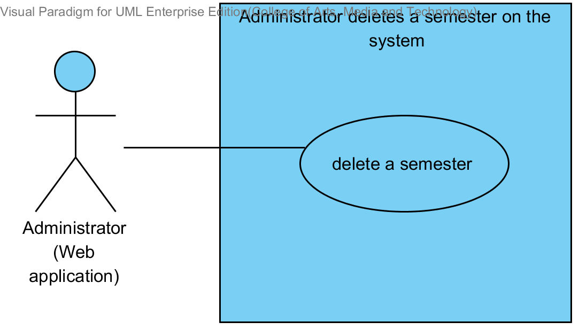

|  |  |  |  |  |
| --- | --- | --- | --- | --- |
| **Use Case ID:** | UC 10.1 | | | |
| **Use Case Name:** | Administrator can delete a semester | | | |
| **Created By:** | Mr.Tanadol Parn-ong | | **Last Updated By:** | Mr.Tanadol Parn-ong |
| **Date Created:** | 10/05/2014 | | **Last Revision Date:** | 10/05/2014 |
| **Actors:** | | Administrator | | |
| **Description:** | | This use case is provided for Administrator delete a semester on the web application. | | |
| **Trigger:** | | Administrator enters the Semester page. | | |
| **Preconditions:** | | Semester information should be in the system. | | |
| **Post conditions:** | | The system display “Deletion Semester Successful” message. | | |
| **Normal Flow:** | | 1. Administrator enters the Semester main page. 2. The system displays the Semester main page interface. 3. Administrator select a semester academic year that want to delete. 4. Administrator submits deletion semester academic year form. 5. The system display “Deletion Semester Successful” message. | | |
| **Alternative Flows:** | | N/A | | |
| **Exceptions:** | | N/A | | |
| **Includes:** | | N/A | | |
| **Frequency of Use:** | | Often | | |
| **Assumptions:** | | N/A | | |
| **Notes and Issues:** | | N/A | | |

**URS10.1 Administrator can delete a semester.**

Administrator can delete a semester.

**Actor:** Administrator

**Prerequisite:** Administrator must have logged**.**

**Input: None**

**Flow of Execution:**

1. Administrator enters the Semester main page.
2. Administrator select a semester academic year that want to delete.
3. Administrator submits deletion semester academic year form

**AC-10.1 Administrator can delete a semester.**

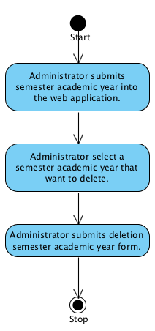

**System Requirement Specification of URS10.1**

**SRS 8-1.1:** The system shall redirect to the Semester main page interface.

**SRS 10-2.1:** The system shall display “Deletion Semester Successful” message.

**SRS 10-3.1:** The system shall delete the semester in the database table.

## **4.11 Administrator can create a course. (UC11.1)**

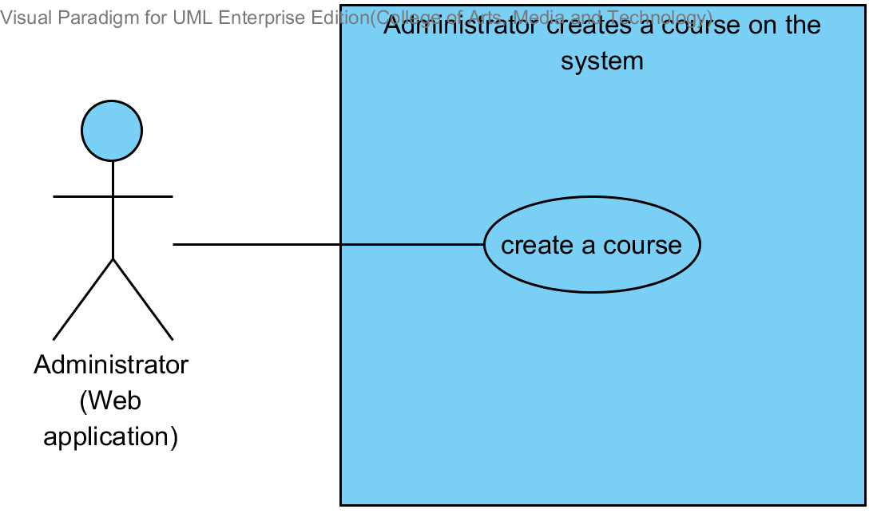

|  |  |  |  |  |
| --- | --- | --- | --- | --- |
| **Use Case ID:** | UC 11.1 | | | |
| **Use Case Name:** | Administrator can create a course | | | |
| **Created By:** | Mr.Tanadol Parn-ong | | **Last Updated By:** | Mr.Tanadol Parn-ong |
| **Date Created:** | 10/05/2014 | | **Last Revision Date:** | 10/05/2014 |
| **Actors:** | | Administrator | | |
| **Description:** | | This use case is provided for Administrator create a course on the web application. | | |
| **Trigger:** | | Administrator enters the Course management page. | | |
| **Preconditions:** | | Semester should be in the system. | | |
| **Post conditions:** | | The system display “Adding Course Successful” message. | | |
| **Normal Flow:** | | 1. Administrator enters the Course management page. 2. The system displays Course management page. 3. Administrator selects a semester that want to create course in that semester. 4. Administrator submits a semester. 5. The system displays Course main page. 6. Administrator enters to Course main page. 7. Administrator clicks add course in Course main page. 8. The system displays Course Addition page. 9. Administrator enters the Course Addition page. 10. Administrator provides course information into the web application. 11. Administrator submit the course information form into the web application. 12. The system validate course information from Administrator. 13. The system redirects to the Student registration page. 14. Administrator add a list of students to Course. 15. Administrator submit a list of student to Course into the web application. 16. The system display “Adding Course Successful” message. | | |
| **Alternative Flows:** | | 12A. if Administrator input data in the wrong format, the system should provide the error message as followed:  1. The wrong credit format: The error message is “The course credit must be number only”  2. Use Case resumes on step 10 of normal flow | | |
| **Exceptions:** | | N/A | | |
| **Includes:** | | N/A | | |
| **Frequency of Use:** | | Often | | |
| **Assumptions:** | | N/A | | |
| **Notes and Issues:** | | N/A | | |

**URS11.1 Administrator can create a course.**

Administrator can create a course by providing course name, course credit, course description, lecturer name. Administrator can register a list of students to a course.

**Actor:** Administrator

**Prerequisite:** Administrator must have logged**.**

**Input:**

|  |  |  |  |
| --- | --- | --- | --- |
| Name | Description | Example | Remarks |
| course name | Can be any character is allowed. | “Computer programming” |  |
| course credit | Only number is allowed. | 3 |  |
| course description | Can be any character is allowed. | Computer programing is a learn process that leads from an original formulation of a computing problem to executable programs. |  |
| lecturer name | Administrator select a lecturer name by selecting from the database. | “Dr. Tony Stark’’ |  |

**Flow of Execution:**

1. Administrator enters the Course management page.
2. Administrator selects a semester that want to create course in that semester**.**
3. Administrator submits a semester**.**
4. Administrator enters to Course main page**.**
5. Administrator clicks add course in Course main page**.**
6. Administrator enters the Course Addition page**.**
7. Administrator provides course information into the web application**.**
8. Administrator submit the course information form into the web application**.**
9. Administrator add a list of students to Course**.**
10. Administrator submit a list of student to Course into the web application**.**

**Alternative Flow**

7A. if Administrator input data in the wrong format, the system should provide the error message as followed:

* + The wrong credit format: The error message is “The course credit must be number only”

**AC-11.1 Administrator can create a course.**

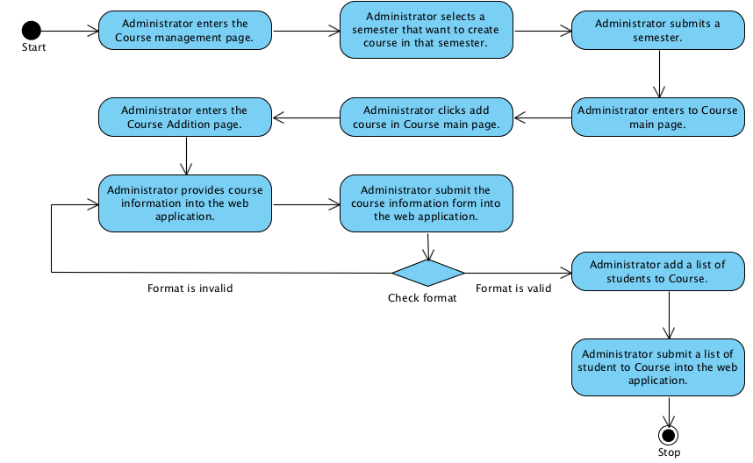

**System Requirement Specification of URS11.1**

**SRS 11-1.1:** The system shall display Course management page.

**SRS 11-2.1:** The system shall display Course main page.

**SRS 11-3.1:** The system shall display Course Addition page.

**SRS 11-4.1:** The system shall validate course information from Administrator.

**SRS 11-5.1:** The system shall redirects to the Student registration page.

**SRS 11-6.1:** The system shall display “Adding Course Successful” message.

**SRS 11-7.1:** The system shall display “The course credit must be number only” message.

## **4.12 Administrator can edit a course. (UC 12.1)**

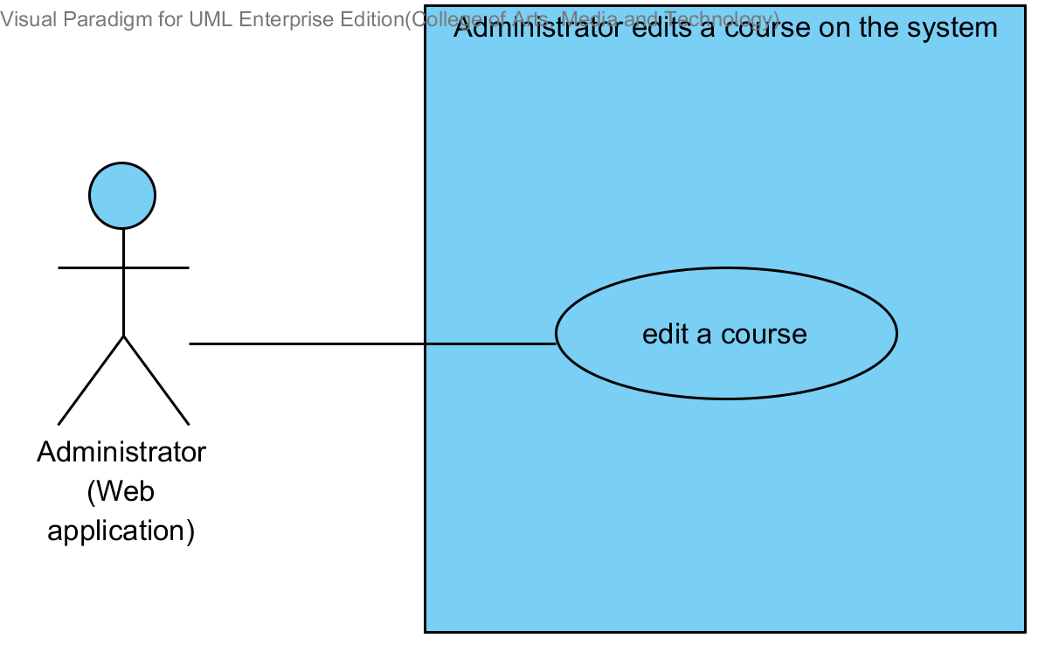

|  |  |  |  |  |
| --- | --- | --- | --- | --- |
| **Use Case ID:** | UC 12.1 | | | |
| **Use Case Name:** | Administrator can edit Course | | | |
| **Created By:** | Mr.Tanadol Parn-ong | | **Last Updated By:** | Mr.Tanadol Parn-ong |
| **Date Created:** | 10/05/2014 | | **Last Revision Date:** | 10/05/2014 |
| **Actors:** | | Administrator | | |
| **Description:** | | This use case is provided for Administrator edit course information. | | |
| **Trigger:** | | Administrator enters to Course information page. | | |
| **Preconditions:** | | Course information should be in the system. | | |
| **Post conditions:** | | The system display “editing Course Successful” message. | | |
| **Normal Flow:** | | 1. Administrator enters Course information page. 2. The system displays Course information page interface. 3. Administrator provides course information for editing. 4. Administrator submits edit course form. 5. The system validate course information from Administrator. 6. The system display “editing Course Successful” message. | | |
| **Alternative Flows:** | | 3A. Administrator remove students from the course.   1. Administrator selects students. 2. Administrator drops student form into the web application. 3. Flow of execution resumes to step 4.   3B. Administrator adds students to the course.   1. Administrator enter Update student in course page. 2. The system display Update student in course page interface. 3. Administrator selects a list of students for adding in the course. 4. Administrator submit the add student form into the web application.   Flow of execution resumes to step 2.  5A. if Administrator input data in the wrong format, the system should provide the error message as followed:  1. The wrong credit format: The error message is “The course credit must be number only”  2 Use Case resumes on step 3 of normal flow | | |
| **Exceptions:** | | N/A | | |
| **Includes:** | | N/A | | |
| **Frequency of Use:** | | Often | | |
| **Assumptions:** | | N/A | | |
| **Notes and Issues:** | | N/A | | |

**URS12.1 Administrator can edit a course.**

Administrator can edit a course by providing course name, course credit, course description, lecturer name. Administrator can add or remove students from a course.

**Actor:** Administrator

**Prerequisite:** Administrator must have logged**.**

**Input:**

|  |  |  |  |
| --- | --- | --- | --- |
| Name | Description | Example | Remarks |
| course name | Can be any character is allowed. | “SE101” |  |
| course credit | Only number is allowed. | 3 |  |
| course description | Can be any character is allowed. | Se101 is a basic java programming. |  |
| lecturer name | Administrator select a lecturer name by selecting from the database. | “Aj. Tom” |  |

**Flow of Execution:**

1. Administrator enters Course information page.
2. Administrator provides course information for editing.
3. Administrator submits edit course form.

**Alternative Flow**

2A. Administrator remove students from the course.

1. Administrator selects students.
2. Administrator drops student form into the web application.
3. Flow of execution resumes to step 3.

3B. Administrator adds students to the course.

1. Administrator enter Update student in course page.
2. Administrator selects a list of students for adding in the course.
3. Administrator submit the add student form into the web application.

Flow of execution resumes to step 1.

3A. if Administrator input data in the wrong format, the system should provide the error message as followed:

* + The wrong credit format: The error message is “The course credit must be number only”

**AC-12.1 Administrator can edit a course.**

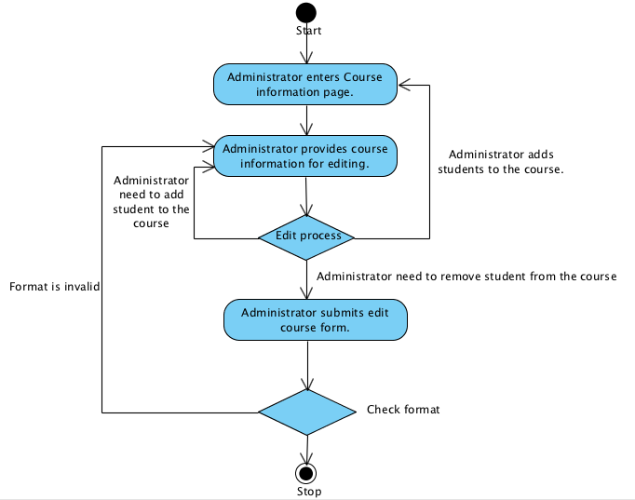

**System Requirement Specification of URS12.1**

**SRS 12-1.1:** The system shall display Course information page interface.

**SRS 12-2.1:** The system shall validate course information from Administrator.

**SRS 12-3.1:** The system shall display Update student in course page interface.

**SRS 12-4.1:** The system shall update course information in the database table.

**SRS 12-5.1:** The system shall display “Editing Course Successful” message

## **4.13 Administrator can delete a course. (UC 13.1)**

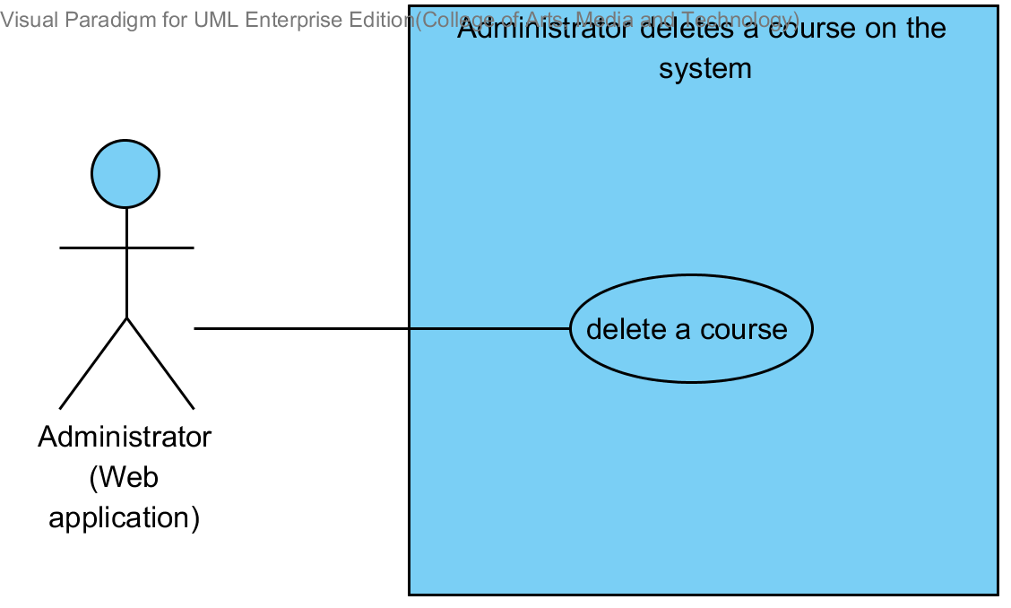

|  |  |  |  |  |
| --- | --- | --- | --- | --- |
| **Use Case ID:** | UC 13.1 | | | |
| **Use Case Name:** | Administrator can delete a course | | | |
| **Created By:** | Mr.Tanadol Parn-ong | | **Last Updated By:** | Mr.Tanadol Parn-ong |
| **Date Created:** | 10/05/2014 | | **Last Revision Date:** | 10/05/2014 |
| **Actors:** | | Administrator | | |
| **Description:** | | This use case is provided for Administrator delete course. | | |
| **Trigger:** | | Administrator click Delete course button. | | |
| **Preconditions:** | | Administrator must logged in. | | |
| **Post conditions:** | | The course was deleted | | |
| **Normal Flow:** | | 1. Administrator enters Course information page. 2. The system displays Course information page interface. 3. Administrator submits Delete course form. 4. The system displays confirm message to delete on the Course information page. 5. Administrator clicks “yes” button. 6. The system display “Deleting Course Successful” message. | | |
| **Alternative Flows:** | | N/A | | |
| **Exceptions:** | | N/A | | |
| **Includes:** | | N/A | | |
| **Frequency of Use:** | | Often | | |
| **Assumptions:** | | N/A | | |
| **Notes and Issues:** | | N/A | | |

**URS13.1 Administrator can delete a course.**

Administrator can delete a course.

**Actor:** Administrator

**Prerequisite:** Administrator must have logged**.**

**Input: None**

**Flow of Execution:**

1. Administrator enters Course information page.
2. Administrator submits Delete course form.
3. Administrator clicks “yes” button.

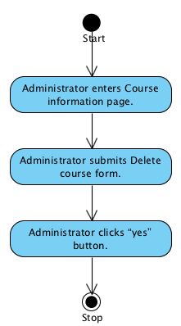

**System Requirement Specification of URS13.1**

**SRS 12-1.1:** The system shall display Course information page interface.

**SRS 12-2.1:** The system shall validate course information from Administrator.

**SRS 12-3.1:** The system shall display Update student in course page interface.

**SRS 13-1.1:** The system shall display confirm message to delete on the Course information page.

**SRS 13-2.1:** The system shall delete course in the database table.

**SRS 13-3.1:** The system shall display “Deleting Course Successful” message.

## **4.14 Lecturer can view course information. (UC 14.1)**

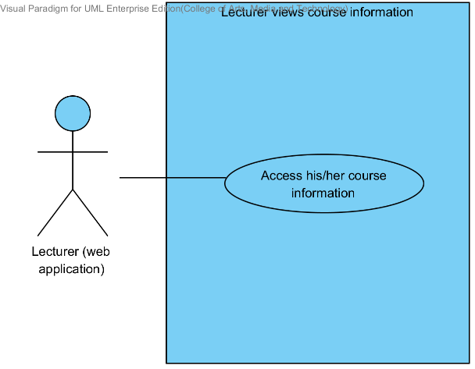

|  |  |  |  |  |
| --- | --- | --- | --- | --- |
| **Use Case ID:** | UC 14.1 | | | |
| **Use Case Name:** | Lecturer views course information. | | | |
| **Created By:** | Mr.Tanadol Parn-ong | | **Last Updated By:** | Mr.Tanadol Parn-ong |
| **Date Created:** | 10/05/2014 | | **Last Revision Date:** | 10/05/2014 |
| **Actors:** | | Lecturer | | |
| **Description:** | | This use case is provided for Lecturer views his/her course information on the web application. | | |
| **Trigger:** | | Lecturer enters to Course management page. | | |
| **Preconditions:** | | Lecturer must logged in to the system. | | |
| **Post conditions:** | | Lecturer sees the course information on the web application. | | |
| **Normal Flow:** | | 1. Lecturer enters to Course management page. 2. The system redirects to Course management page on the web application 3. The system provide all semester on Course management page. 4. Lecturer enters to Course main page. 5. The system redirects to Course main page on the web application. 6. The system provides all courses name in Course main page on the web application which were taught by finding from lecturer ID. 7. Lecturer selects a course that want to view. 8. Lecturer submits viewing course information form. 9. The system redirects to Course information page interface on the web application, including course name, course credit, course description, lecturer name, a list of students in the course. 10. The system fetches the course information from the system to display into Course information page on the web application. | | |
| **Alternative Flows:** | | N/A | | |
| **Exceptions:** | | N/A | | |
| **Includes:** | | N/A | | |
| **Frequency of Use:** | | Often | | |
| **Assumptions:** | | N/A | | |
| **Notes and Issues:** | | N/A | | |

**URS 14.1 Lecturer can view courses information.**

Lecturer can view a course information into the web application.

**Actor:** Lecturer

**Prerequisite:** Lecturer must have logged**.**

**Input:** None

**Flow of Execution:**

1. Lecturer enters to Course management page.
2. Lecturer enters to Course main page
3. Lecturer selects a course that want to view.
4. Lecturer submits viewing course information form.

**AC-14.1 Lecturer can view courses information.**

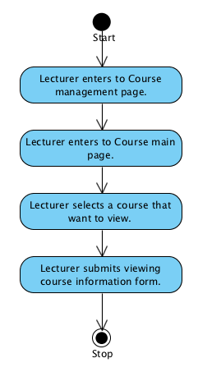

**System Requirement Specification of URS 14.1**

**SRS 14-1.1:** The system shall redirect to Course management page on the mobile application.

**SRS 14-2.1:** The system shall provide all semester on Course management page

**SRS 14-3.1:** The system shall provide all courses name in Course main page on the web application which were taught by finding from lecturer ID.

**SRS 14-4.1:** The system shall redirect to Course main page on the web application.

**SRS 14-5.1:** The system shall redirect to Course information page interface on the web application, including course name, course credit, course description, lecturer name, a list of students in the course.

**SRS 14-6.1:** The system shall fetch the course information from the system to display into Course information page on the web application.

## **4.15 Student can view course information. (UC 15.1)**

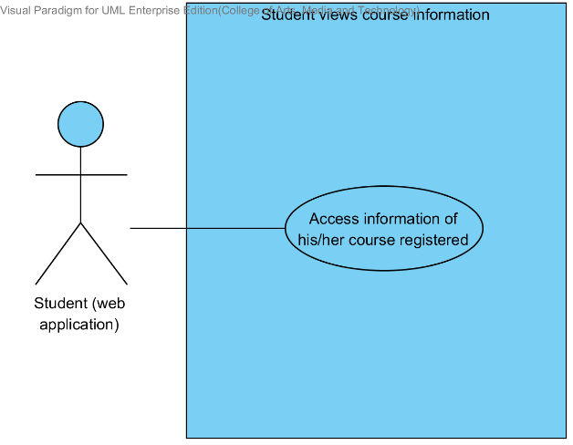

|  |  |  |  |  |
| --- | --- | --- | --- | --- |
| **Use Case ID:** | UC 15.1 | | | |
| **Use Case Name:** | Student views course information. | | | |
| **Created By:** | Mr.Tanadol Parn-ong | | **Last Updated By:** | Mr.Tanadol Parn-ong |
| **Date Created:** | 10/05/2014 | | **Last Revision Date:** | 10/05/2014 |
| **Actors:** | | Student | | |
| **Description:** | | This use case is provided for Student views his/her course information on the web application. | | |
| **Trigger:** | | Student enters to Semester page. | | |
| **Preconditions:** | | Student must logged in to the system. | | |
| **Post conditions:** | | Student sees the course information on the web application. | | |
| **Normal Flow:** | | 1. Student enters to Semester page. 2. The system redirects to Semester page interface on the web application. 3. The system provides all semester on Semester page on the web application which were studied by finding from student ID. 4. Student selects a semester. 5. Student submits view overall course form. 6. The system redirects to Overall course page on the web application. 7. The system provides all courses name in Overall course page on the web application which were studied by finding from student ID. 8. Student selects a course that want to view. 9. Student submits viewing course information form. 10. The system redirects to Course information page interface on the web application, including course name, course credit, course description, lecturer name, a list of students in the course. 11. The system fetches the course information from the system to display into Course information page on the web application. | | |
| **Alternative Flows:** | | N/A | | |
| **Exceptions:** | | N/A | | |
| **Includes:** | | N/A | | |
| **Frequency of Use:** | | Often | | |
| **Assumptions:** | | N/A | | |
| **Notes and Issues:** | | N/A | | |

**URS 15.1 Student can view courses information.**

Student can view a course information into the web application.

**Actor:** Student

**Prerequisite:** Student must have logged**.**

**Input:** None

**Flow of Execution:**

1. Student enters to Semester page.
2. Student selects a semester.
3. Student submits view overall course form.
4. Student selects a course that want to view.
5. Student submits viewing course information form.

**AC-15.1 Student can view courses information.**

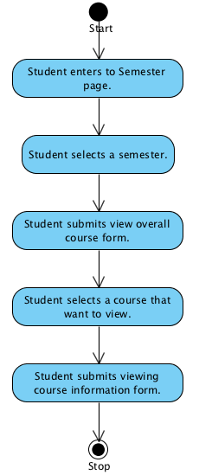

**System Requirement Specification of URS 15.1**

**SRS 15-1.2:** The system redirects to Semester page interface on the web application.

**SRS 15-2.2:** The system provides all semester on Semester page on the web application which were studied by finding from student ID.

**SRS 15-3.2:** The system redirects to Overall course page on the web application.

**SRS 15-4.2:** The system provides all courses name in Overall course page on the web application which were studied by finding from student ID.

**SRS 15-35.2:** The system redirects to Course information page interface on the web application, including course name, course credit, course description, lecturer name, a list of students in the course.

**SRS 15-6.2:** The system fetches the course information from the system to display into Course information page on the web application.

## **4.16 Lecturer can assign assignments or quizzes which are multiple choices question, true/false question, and short answers. (UC 16.1)**

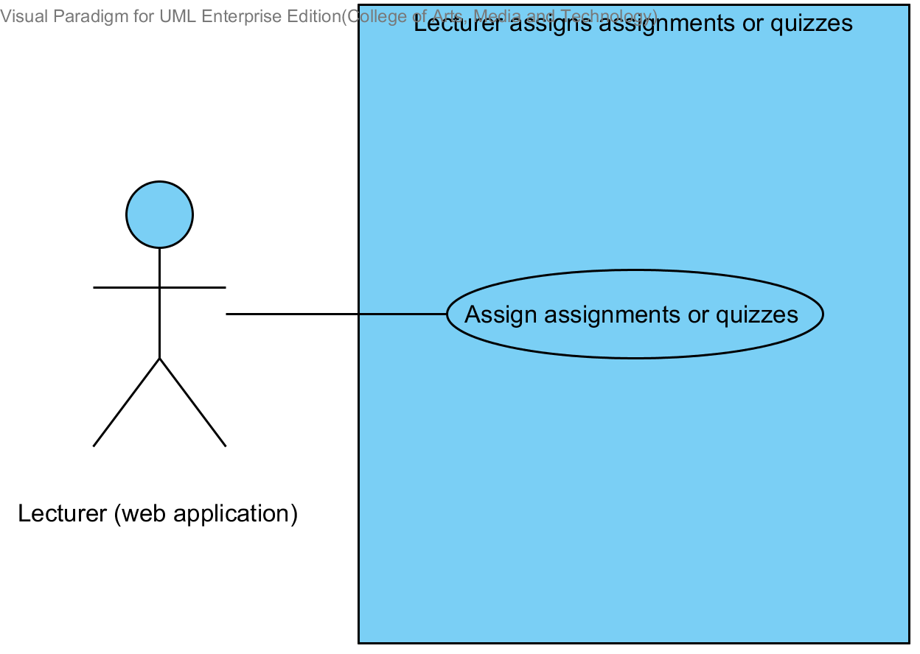

|  |  |  |  |  |
| --- | --- | --- | --- | --- |
| **Use Case ID:** | UC 16.1 | | | |
| **Use Case Name:** | Lecturer assigns assignments or quizzes. | | | |
| **Created By:** | Mr.Tanadol Parn-ong | | **Last Updated By:** | Mr.Tanadol Parn-ong |
| **Date Created:** | 10/05/2014 | | **Last Revision Date:** | 10/05/2014 |
| **Actors:** | | Lecturer | | |
| **Description:** | | This use case is provided for Lecturer assigns assignments or quizzes on the web application. | | |
| **Trigger:** | | Lecturer enters to Overall testing page. | | |
| **Preconditions:** | | Lecturer must logged in to the system. | | |
| **Post conditions:** | | The system displays “Creating Assignment Successful” message on the web application | | |
| **Normal Flow:** | | 1. Lecturer enters to Overall testing page. 2. The system redirects to Overall testing page on the web application. 3. Lecturer submits addition testing form. 4. The system redirects to Addition testing page on the web application. 5. The system provides Addition testing page interface on the web application, including testing name, a type of testing, an amount of questions, a testing score, student name, randomize order of the question status, and posting status. 6. Lecturer provides testing information which consist testing name, a type of testing, an amount of questions, a testing score, student name, randomize order of the question status, and posting status into the Addition testing page. 7. Lecturer submits testing information into web application. 8. The system validates testing information from Lecturer. 9. Lecturer enters to Assign assignment and quiz page on the web application. 10. The system redirects to Assigning assignment and quiz page on the web application. 11. The system provides Assign assignment and quiz page interface on the web application, including a type of question, question description, choice description, a solution, and a question point for Lecturer assigns assignments or quizzes into the system. 12. Lecturer provides assignment or quiz information which consist a type of question (Multiple choices), question description, choice description, a solution, and a question point. 13. Lecturer submits assignment or quiz information into web application. 14. The system validates assignment or quiz information from Lecturer. 15. The system redirects to confirm creating testing page. 16. Lecturer submits creating testing form. 17. The system stores the testing information from Lecturer into the system. 18. The system stores assignment or quiz information from Lecturer into the system. 19. The system displays “Creating Assignment Successful” message on the web application | | |
| **Alternative Flows:** | | 8A when the amount of questions format is wrong. The system provides the error message as followed:  1. The system displays “Amount of questions must be number only” on the web application.  2. Use Case resumes on step 6 of normal flow.  8B when the testing score format is wrong. The system provides the error message as followed:  1. The system displays “Testing score must be number only” on the web application.  2. Use Case resumes on step 6 of normal flow.  12A if Lecturer provides type of question is true/false question.  1. Lecturer provides question description, choice description, a solution, and a question point.  2. Lecturer submits assignment or quiz information into web application  3. Use Case resumes on step 14 of normal flow.  12B if Lecturer provides type of question is short answer.  1. Lecturer provides question description, and a question point.  2. Lecturer submits assignment or quiz information into web application  3. Use Case resumes on step 14 of normal flow.  14A when the multiple choices answer format is wrong. The system provides the error message as followed:  1. The system displays “Answer must be a, b, c, and d only” on the web application.  2. Use Case resumes on step 12 of normal flow.  14B when the true/false answer format is wrong. The system provides the error message as followed:  1. The system displays “Answer must be a and b only” on the web application.  2. Use Case resumes on step 12 of normal flow.  14C when the question point format is wrong. The system provides the error message as followed:  1. The system displays “Question point must be number only” on the web application.  2. Use Case resumes on step 6 of normal flow  19A if Lecturer assigns quizzes, the system provides the error message as followed:  1. The system displays “Creating Quiz Successful” message on the web application | | |
| **Exceptions:** | | N/A | | |
| **Includes:** | | N/A | | |
| **Frequency of Use:** | | Often | | |
| **Assumptions:** | | N/A | | |
| **Notes and Issues:** | | N/A | | |

**URS 16.1 Lecturer can assign assignments or quizzes which are multiple choices question, true/false question, and short answers.**

Lecturer can assign assignments or quizzes into the web application. Lecturer can limit access to the assignment or quiz of authority. Lecturer must provide testing name, type of testing, an amount of questions, testing score, type of question, question information, student name, randomize order of the question status, and posting status.

Lecturer must provide question information by separating from type of questions.

* Lecturer can assign multiple choices questions which provide type of question, question description, choice description, a solution, and question point.
* Lecturer can assign true/false questions which provide type of question, questions description, choice description, a solution, and question point.
* Lecturer can assign short answers which provide type of question, questions description, and question point.

**Actor:** Lecturer

**Prerequisite:** Lecturer must have logged**.**

**Input:**

|  |  |  |  |
| --- | --- | --- | --- |
| Name | Description | Example | Remarks |
| testing name | Can be any character only. | Math testing |  |
| type of testing | The system provides two types of testing which are assignment and quiz. Lecturer must select one type only. | Assignment |  |
| amount of question | Only number is allowed. | 3 |  |
| testing score | Only number is allowed | 100 |  |
| student name | Lecturer adds a list of students for limiting access to the assignment or quiz. | 542115099, 542115091 |  |
| randomize order of the question status | This status is showing status of random order of the question to student. | random |  |
| Posting status | Status is an available and not available. | available |  |

Multiple choices question

|  |  |  |  |
| --- | --- | --- | --- |
| Name | Description | Example | Remarks |
| type of question | The system provides three types of question which are multiple choices, true/false question, and short answer. Lecturer must select one type only. | Multiple choices |  |
| question description | Can be any character is allowed. | What is an answer of 1+1? |  |
| choice description | Choices must have four choices. Can be any character is allowed. | a. 2 b. 1 c. 3 d. 5 |  |
| solution | Only “a, b, c, d” is allowed. | a |  |
| question point | Only number is allowed. | 1 |  |

True/false question

|  |  |  |  |
| --- | --- | --- | --- |
| Name | Description | Example | Remarks |
| type of question | The system provides three types of question which are multiple choices, true/false question, and short answer. Lecturer must select one type only. | True/false question |  |
| question description | Can be any character is allowed. | Answer of 1+1 is 2. |  |
| choice description | Choices must have two choices. Can be true and false is allowed. | a. false  b. true |  |
| solution | Only “a, b, c, d” is allowed. | b |  |
| question point | Only number is allowed. | 1 |  |

Short answer

|  |  |  |  |
| --- | --- | --- | --- |
| Name | Description | Example | Remarks |
| type of question | The system provides three types of question which are multiple choices, true/false question, and short answer. Lecturer must select one type only. | Short answer |  |
| question description | Can be any character is allowed. | What is an answer of 1+1? You must explain how to find the answer. |  |
| question point | Only number is allowed. | 1 |  |

**Flow of Execution:**

1. Lecturer enters to Overall testing page.
2. Lecturer submits addition testing form.
3. Lecturer provides testing information which consist testing name, a type of testing, an amount of questions, a testing score, student name, a randomize order of the question status, and posting status into the Addition testing page.
4. Lecturer submits testing information into web application.
5. Lecturer enters to Assign assignment and quiz page on the web application.
6. Lecturer provides assignment or quiz information which consist a type of question (Multiple choices), question description, choice description, a solution, and a question point.
7. Lecturer submits assignment or quiz information into web application.

Lecturer submits creating testing form.

**Alternative Flow:**

4A. if Lecturer input data in the wrong format, the system should provide the error message as followed:

* + The wrong amount of questions format: The error message is “Amount of questions must be number only”

4B. if Lecturer input data in the wrong format, the system should provide the error message as followed:

* + The wrong testing score format: The error message is “Testing score must be number only”

6A. Lecturer provides type of question is true/false question.

1. Lecturer provides question description, choice description, a solution, and a question point.
2. Lecturer submits assignment or quiz information into web application.
3. Flow of execution resumes to step 5.

6B. Lecturer provides type of question is short answer.

1. Lecturer provides question description, and a question point.
2. Lecturer submits assignment or quiz information into web application.
3. Flow of execution resumes to step 5.

7A if Lecturer input data in the wrong format in multiple choices answer the system should provide the error message as followed:

* + The wrong answer format: The error message is “Answer must be a, b, c, and d only”

7B if Lecturer input data in the wrong format in true/false answer the system should provide the error message as followed:

* + The wrong answer format: The error message is “Answer must be a and b only”

7C. if Lecturer input data in the wrong format, the system should provide the error message as followed:

* + The wrong question point format: The error message is “Question point must be number only”

8A if Lecturer creates a quiz is completed, the system should provide the Successful massage as followed:

* + The system display “Creating Quiz Successful” message.

8B if Lecturer creates an assignment is completed, the system should provide the Successful massage as followed:

* + The system display “Creating Assignment Successful” message.

**AC-16.1 Lecturer can assign assignments or quizzes which are multiple choices question, true/false question, and short answers.**

**System Requirement Specification of 16.1**

**SRS 16-1.1:** The system shall redirect to Overall testing page on the web application.

**SRS 16-2.1:** The system shall redirect to Addition testing page on the web application.

**SRS 16-3.1:** The system shall provide Addition testing page interface on the web application, including testing name, a type of testing, an amount of questions, a testing score student name, randomize order of the question status, and posting status for Lecturer adds an assignment or quiz into the system.

**SRS 16-4.1:** The system shall validate testing information from Lecturer.

**SRS 16-5.1:** The system shall redirect to Assigning assignment and quiz page on the web application.

**SRS 16-6.1:** The system shall provide Assign assignment and quiz page interface on the web application, including a type of question, question description, choice description, an answer, and a question point for Lecturer assigns assignments or quizzes into the system.

**SRS 16-7.1:** The system shall validate assignment or quiz information from Lecturer.

**SRS 16-8.1:** The system shall store the testing information from Lecturer into the system.

**SRS 16-9.1:** The system shall store assignment or quiz information from Lecturer into the system.

**SRS 16-10.1:** The system shall display “Amount of questions must be number only” message when the amount of questions format is wrong.

**SRS 16-11.1:** The system shall display “Answer must be a, b, c, and d only” message when the multiple choices answer format is wrong.

**SRS 16-12.1:** The system shall display “Answer must be a and b only” message when the true/false answer format is wrong.

**SRS 16-13.1:** The system shall display “Testing score must be number only” message when the testing score format is wrong.

**SRS 16-14.1:** The system shall display “Question point must be number only” message when the question point format is wrong.

**SRS 16-15.1:** The system shall display “Creating Assignment Successful” message when Lecturer assign an assignment is successful.

**SRS 16-16.1:** The system shall display “Creating Quiz Successful” message when Lecturer assign a quiz is successful.

**SRS 16-17.1:** The system shall redirect to confirm creating testing page.

## **4.17 Lecturer can edit assignments or quizzes information which are multiple choices question, true/false question, and short answers. (UC 17.1)**

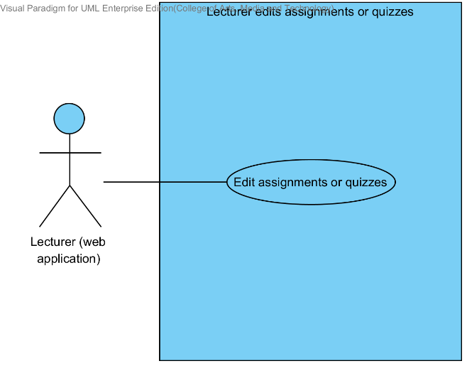

|  |  |  |  |  |
| --- | --- | --- | --- | --- |
| **Use Case ID:** | UC 17.1 | | | |
| **Use Case Name:** | Lecturer edits assignments or quizzes. | | | |
| **Created By:** | Mr.Tanadol Parn-ong | | **Last Updated By:** | Mr.Tanadol Parn-ong |
| **Date Created:** | 10/05/2014 | | **Last Revision Date:** | 10/05/2014 |
| **Actors:** | | Lecturer | | |
| **Description:** | | This use case is provided for Lecturer edits assignments or quizzes on the web application. | | |
| **Trigger:** | | Lecturer select a testing that want to edit. | | |
| **Preconditions:** | | Lecturer must logged in to the system. | | |
| **Post conditions:** | | The system displays “Editing Assignment Successful” message on the web application. | | |
| **Normal Flow:** | | 1. Lecturer select a testing that want to edit. 2. Lecturer submits edition testing form. 3. The system redirects to Edition testing page on the web application. 4. The system provides Edition testing page interface on the web application, including testing name, a type of testing, an amount of questions, a testing score, student name, randomize order of the question status, and posting status. 5. The system fetches the testing information from the system to display on Edition testing page on the web application. 6. Lecturer provides testing name, type of testing, an amount of questions, a testing score, student name, randomize order of the question status, and posting status into the testing page. 7. Lecturer submits testing information into web application. 8. The system validates testing information from Lecturer. 9. Lecturer enters to Edition assignment and quiz page on the web application. 10. The system redirects to Edition assignment and quiz page on the web application. 11. The system fetches the assignment or quiz information from the system to display on Edition assignment and quiz page on the web application. 12. The system provides Edition assignment and quiz page interface on the web application, including a type of question, question description, choice description, a solution, and a question point. 13. Lecturer provides type of question (Multiple choices), question description, choice description, a solution, and a question point. 14. Lecturer submits assignment or quiz information into web application. 15. The system validates assignment or quiz information from Lecturer. 16. The system redirects to confirm edition testing page. 17. Lecturer submits editing testing form. 18. The system updates the testing information from Lecturer into the system. 19. The system updates assignment or quiz information from Lecturer into the system. 20. The system displays “Editing Assignment Successful” message on the web application. | | |
| **Alternative Flows:** | | 8A when the amount of questions format is wrong. The system provides the error message as followed:  1. The system displays “Amount of questions must be number only” on the web application.  2. Use Case resumes on step 8 of normal flow.  8B when the testing score format is wrong. The system provides the error message as followed:  1. The system displays “Testing score must be number only” on the web application.  2. Use Case resumes on step 8 of normal flow.  13A if Lecturer provides type of question is true/false question.  1. Lecturer provides question description, choice description, a solution, and a question point.  2. Lecturer submits assignment or quiz information into web application  3. Use Case resumes on step 15 of normal flow.  13B if Lecturer provides type of question is short answer.  1. Lecturer provides question description, and a question point.  2. Lecturer submits assignment or quiz information into web application  3. Use Case resumes on step 15 of normal flow.  15A when the multiple choices answer format is wrong. The system provides the error message as followed:  1. The system displays “Answer must be a, b, c, and d only” on the mobile application.  2. Use Case resumes on step 13 of normal flow.  15B when the true/false answer format is wrong. The system provides the error message as followed:  1. The system displays “Answer must be a and b only” on the mobile application.  2. Use Case resumes on step 13 of normal flow.  15C when the question point format is wrong. The system provides the error message as followed:  1. The system displays “Question point must be number only” on the mobile application.  2. Use Case resumes on step 13 of normal flow  20A if Lecturer edits quizzes, the system provides the error message as followed:  1. The system displays “Editing Quiz Successful” message on the web application | | |
| **Exceptions:** | | N/A | | |
| **Includes:** | | N/A | | |
| **Frequency of Use:** | | Often | | |
| **Assumptions:** | | N/A | | |
| **Notes and Issues:** | | N/A | | |

**URS 17.1 Lecturer can edit assignments or quizzes information which are multiple choices question, true/false question, and short answers.**

Lecturer can edit assignments or quizzes information into the web application. Lecturer can limit access to the assignment or quiz of authority. Lecturer must provide testing name, type of testing, an amount of questions, testing score, type of question, question information, student name, randomize order of the question status, and posting status.

Lecturer must provide question information by separating from type of questions.

* Lecturer can edit multiple choices questions which provide type of question, question description, choice description, a solution, and a question point.
* Lecturer can edit true/false questions which provide type of question, questions description, choice description, a solution, and a question point.
* Lecturer can edit short answers which provide type of question, questions description, and a question point.

**Actor:** Lecturer

**Prerequisite:** Lecturer must have logged**.**

**Input:**

|  |  |  |  |
| --- | --- | --- | --- |
| Name | Description | Example | Remarks |
| testing name | Can be any character only. | Math testing |  |
| type of testing | The system provides two types of testing which are assignment and quiz. Lecturer must select one type only. | Assignment |  |
| amount of question | Only number is allowed. | 3 |  |
| testing score | Only number is allowed | 100 |  |
| student name | Lecturer adds a list of students for limiting access to the assignment or quiz. | 542115099, 542115091,  542115092 |  |
| randomize order of the question status | This status is showing status of random order of the question to student. | random |  |
| Posting status | Status is an available and not available. | Available |  |

Multiple choices question

|  |  |  |  |
| --- | --- | --- | --- |
| Name | Description | Example | Remarks |
| type of question | The system provides three types of question which are multiple choices, true/false question, and short answer. Lecturer must select one type only. | Multiple choices |  |
| question description | Can be any character is allowed. | What is an answer of 1+1? |  |
| choice description | Choices must have four choices. Can be any character is allowed. | a. 2 b. 1 c. 3 d. 5 |  |
| solution | Only “a, b, c, d” is allowed. | a |  |
| question point | Only number is allowed | 1 |  |

True/false question

|  |  |  |  |
| --- | --- | --- | --- |
| Name | Description | Example | Remarks |
| type of question | The system provides three types of question which are multiple choices, true/false question, and short answer. Lecturer must select one type only. | True/false question |  |
| question description | Can be any character is allowed. | Answer of 1+1 is 2. |  |
| choice description | Choices must have two choices. Can be true and false is allowed. | a. false  b. true |  |
| solution | Only “a, b, c, d” is allowed. | b |  |
| question point | Only number is allowed | 1 |  |

Short answer

|  |  |  |  |
| --- | --- | --- | --- |
| Name | Description | Example | Remarks |
| type of question | The system provides three types of question which are multiple choices, true/false question, and short answer. Lecturer must select one type only. | Short answer |  |
| question description | Can be any character is allowed. | What is an answer of 1+1? You must explain how to find the answer. |  |
| question point | Only number is allowed | 1 |  |

**Flow of Execution:**

1. Lecturer selects a testing that want to edit.
2. Lecturer submits edition testing form.
3. Lecturer provides testing name, type of testing, an amount of questions, testing score, student name, randomize order of the question status, and posting status into the testing page.
4. Lecturer submits testing information into web application.
5. Lecturer enters to Edition assignment and quiz page on the web application.
6. Lecturer provides type of question (Multiple choices), question description, choice description, a solution, and question point.
7. Lecturer submits assignment or quiz information into web application.
8. Lecturer submits editing testing form.

**Alternative Flow:**

4A. if Lecturer input data in the wrong format, the system should provide the error message as followed:

* + The wrong amount of questions format: The error message is “Amount of questions must be number only”

4B. if Lecturer input data in the wrong format, the system should provide the error message as followed:

* + The wrong testing score format: The error message is “Testing score must be number only”

6A. Lecturer provides type of question is true/false question.

1. Lecturer provides question description, choice description, a solution, and question point.
2. Lecturer submits assignment or quiz information into web application.
3. Flow of execution resumes to step 15.

6B. Lecturer provides type of question is short answer.

1. Lecturer provides question description, and question point.
2. Lecturer submits assignment or quiz information into web application.
3. The system validates testing information from Lecturer.
4. Flow of execution resumes to step 15.

7A if Lecturer input data in the wrong format in multiple choices answer the system should provide the error message as followed:

* + The wrong answer format: The error message is “Answer must be a, b, c, and d only”

7B if Lecturer input data in the wrong format in true/false answer the system should provide the error message as followed:

* + The wrong answer format: The error message is “Answer must be a and b only”

7C. if Lecturer input data in the wrong format, the system should provide the error message as followed:

* + The wrong question point format: The error message is “Question point must be number only”

8A if Lecturer edits a quiz is completed, the system should provide the Successful massage as followed:

* + The system display “Editing Quiz Successful” message.

8B if Lecturer edits an assignment is completed, the system should provide the Successful massage as followed:

* + The system display “Editing Assignment Successful” message.

**AC-17.1 Lecturer can edit assignments or quizzes information which are multiple choices question, true/false question, and short answers.**

**System Requirement Specification of URS 17.1**

**SRS 16-4.1:** The system shall validate testing information from Lecturer.

**SRS 16-7.1:** The system shall validate assignment or quiz information from Lecturer.

**SRS 16-10.1:** The system shall display “Amount of questions must be number only” message when the amount of questions format is wrong.

**SRS 16-11.1:** The system shall display “Answer must be a, b, c, and d only” message when the multiple choices answer format is wrong.

**SRS 16-12.1:** The system shall display “Answer must be a and b only” message when the true/false answer format is wrong.

**SRS 16-13.1:** The system shall display “Testing score must be number only” message when the testing score format is wrong.

**SRS 16-14.1:** The system shall display “Question point must be number only” message when the question point format is wrong.

**SRS 17-1.1:** The system shall redirect to Edition testing page on the web application.

**SRS 17-2.1:** The system shall redirects to Edition assignment and quiz page on the web application.

**SRS 17-3.1:** The system shall fetch the testing information from the system to display on Edition testing page on the web application.

**SRS 17-4.1:** The system shall fetch the assignment or quiz information from the system to display on Edition assignment and quiz page on the web application.

**SRS 17-5.1:** The system shall provide Edition testing page interface on the web application, including testing name, a type of testing, an amount of questions, a score testing, student name, randomize order of the question status, and posting status for Lecturer adds an assignment or quiz into the system.

**SRS 17-6.1:** The system shall provide Edition assignment and quiz page interface on the web application, including a type of question, question description, choice description, an answer, and a question point for Lecturer assigns assignments or quizzes into the system.

**SRS 17-7.1:** The system shall update the testing information from Lecturer into the system.

**SRS 17-8.1:** The system shall update assignment or quiz information from Lecturer into the system.

**SRS 17-9.1:** The system shall display “Editing Assignment Successful” message when Lecturer edits an assignment is successful.

**SRS 17-10.1:** The system shall display “Editing Quiz Successful” message when Lecturer edits a quiz is successful.

**SRS 17-11.1:** The system shall redirect to confirm edition testing page.

## **4.18 Lecturer can delete assignments or quizzes which are multiple choices question, true/false question, and short answers. (UC 18.1)**

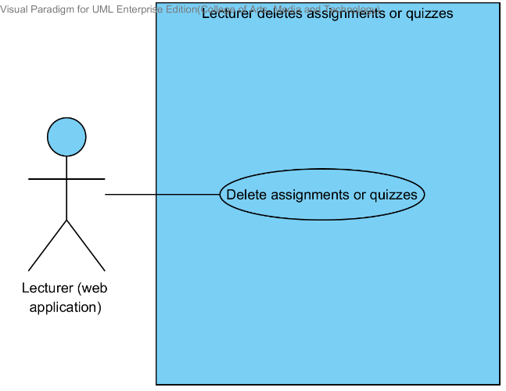

|  |  |  |  |  |
| --- | --- | --- | --- | --- |
| **Use Case ID:** | UC 18.1 | | | |
| **Use Case Name:** | Lecturer deletes assignments or quizzes. | | | |
| **Created By:** | Mr.Tanadol Parn-ong | | **Last Updated By:** | Mr.Tanadol Parn-ong |
| **Date Created:** | 10/05/2014 | | **Last Revision Date:** | 10/05/2014 |
| **Actors:** | | Lecturer | | |
| **Description:** | | This use case is provided for Lecturer deletes assignments or quizzes on the web application. | | |
| **Trigger:** | | Lecturer select a testing that want to delete. | | |
| **Preconditions:** | | Lecturer must logged in to the system. | | |
| **Post conditions:** | | The system shall display “Deleting Assignment Successful” message on the web application. | | |
| **Normal Flow:** | | 1. Lecturer selects a testing that want to delete. 2. Lecturer submits deleting testing form. 3. The system deletes the testing information from the system. 4. The system deletes assignment or quiz information from the system. 5. The system shall display “Deleting Assignment Successful” message on the web application | | |
| **Alternative Flows:** | | 5A if Lecturer deletes a quiz, the system provides the error message as followed:  1. The system displays “Deleting Quiz Successful” message on the web application | | |
| **Exceptions:** | | N/A | | |
| **Includes:** | | N/A | | |
| **Frequency of Use:** | | Often | | |
| **Assumptions:** | | N/A | | |
| **Notes and Issues:** | | N/A | | |

**URS 18.1 Lecturer can delete assignments or quizzes which are multiple choices question, true/false question, and short answers.**

Lecturer can delete assignments or quizzes into the web application.

**Actor:** Lecturer

**Prerequisite:** Lecturer must have logged**.**

**Input:** None

**Flow of Execution:**

1. Lecturer select a testing that want to delete.
2. Lecturer submits deleting testing form.

**AC-18.1 Lecturer can delete assignments or quizzes which are multiple choices question, true/false question, and short answers.**

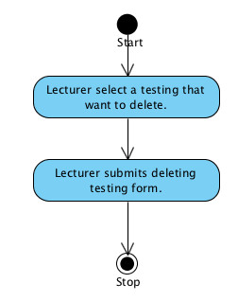

**System Requirement Specification of URS 18.1**

**SRS 18-1.1:** The system shall deletes the testing information from the system.

**SRS 18-2.1:** The system shall deletes assignment or quiz information from the system.

**SRS 18-3.1:** The system shall display “Deleting Assignment Successful” message when Lecturer deletes an assignment is successful.

**SRS 18-4.1:** The system shall display “Deleting Quiz Successful” message when Lecturer deletes a quiz is successful.

## **4.19 Lecturer marks the point for student’s short answer. (UC 19.1)**

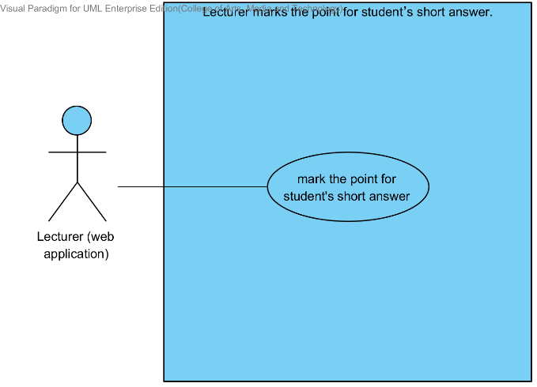

|  |  |  |  |  |
| --- | --- | --- | --- | --- |
| **Use Case ID:** | UC 19.1 | | | |
| **Use Case Name:** | Lecturer marks the point for student’s short answer. | | | |
| **Created By:** | Mr.Tanadol Parn-ong | | **Last Updated By:** | Mr.Tanadol Parn-ong |
| **Date Created:** | 10/05/2014 | | **Last Revision Date:** | 10/05/2014 |
| **Actors:** | | Lecturer | | |
| **Description:** | | This use case is provided for Lecturer marks the point for student’s short answer. | | |
| **Trigger:** | | Lecturer selects a testing that want to mark the point for student’s short answer. | | |
| **Preconditions:** | | Student have already finished taking the assignment or quiz and the answers are recorded in the system. | | |
| **Post conditions:** | | The system displays “Marking point is successful” message on the web application. | | |
| **Normal Flow:** | | 1. Lecturer selects a testing that want to mark the point for student’s short answer. 2. Lecturer submits Marking the point page form. 3. Lecturer enters to Marking the point for student’s short answer page. 4. The system redirects to Marking the point for student’s short answer page on the web application. 5. The system fetches short answer question and student’s short answer from the system. 6. The system displays short answer question and student’s short answer in Marking the point for student’s short answer page on the web application. 7. Lecturer marks points of student in each short answer question. 8. Lecturer submits marking point form. 9. The system validates question point format from Lecturer 10. The system stores point of student into the system. 11. The system displays “Marking point is successful” message in Marking the point for student’s short answer page on the web application. | | |
| **Alternative Flows:** | | 8A when the point of student format is wrong, the system provides the error message as followed:  1. The system displays “Point of student must be number only” message on the web application | | |
| **Exceptions:** | | N/A | | |
| **Includes:** | | N/A | | |
| **Frequency of Use:** | | Often | | |
| **Assumptions:** | | N/A | | |
| **Notes and Issues:** | | N/A | | |

**URS 19.1 Lecturer marks the point for student’s short answer.**

Lecturer can mark the point for student’s short answer in each assignment or quiz.

**Actor:** Lecturer

**Prerequisite:** Lecturer must have logged**.**

**Input:**

|  |  |  |  |
| --- | --- | --- | --- |
| Name | Description | Example | Remarks |
| point of student | Only number is allowed | 1 | question point |

**Flow of Execution:**

1. Lecturer selects a testing that want to mark the point for student’s short answer.
2. Lecturer submits Marking the point page form.
3. Lecturer enters to Marking the point for student’s short answer page.
4. Lecturer marks point of student in each short answer question.
5. Lecturer submits marking point form.

**Alternative Flow:**

5A. if Lecturer input data in the wrong format, the system should provide the error message as followed:

* + The wrong point of student format: The error message is “Point of student must be number only

**AC-19.1 Lecturer marks the point for student’s short answer.**

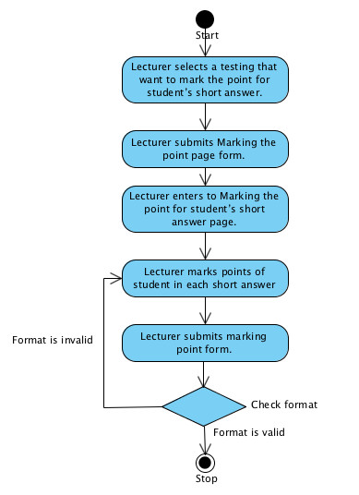

**System Requirement Specification of URS 19.1**

**SRS 19-1.1:** The system shall redirect to Marking the point for student’s short answer page on the web application.

**SRS 19-2.1:** The system shall fetch short answer question and student’s short answer from the system.

**SRS 19-3.1:** The system shall display short answer question and student’s short answer in Marking the point for student’s short answer page on the mobile application.

**SRS 19-4.1:** The system shall validate question point format from Lecturer.

**SRS 19-5.1:** The system shall store point of student into the system.

**SRS 19-6.1:** The system shall display “Marking point is successful” message in Marking the point for student’s short answer page on the web application.

**SRS 19-7.1:** The system shall display “Point of student must be number only” message when the point of student format is wrong.

## **4.20 Lecturer can review overall student’s answer in each choice of assignment or quiz in chart format. (UC 20.1)**

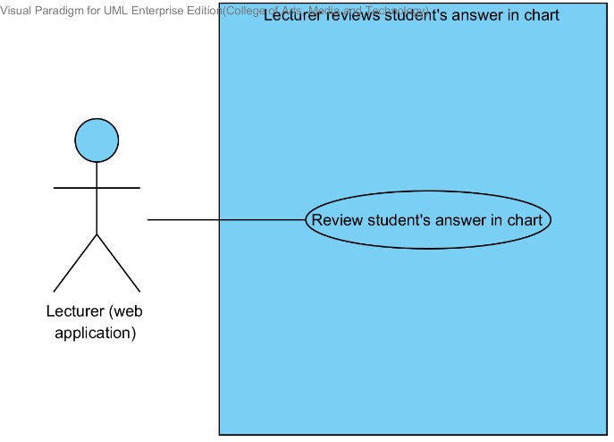

|  |  |  |  |  |
| --- | --- | --- | --- | --- |
| **Use Case ID:** | UC 20.1 | | | |
| **Use Case Name:** | Lecturer reviews student’s answers in chart | | | |
| **Created By:** | Mr.Tanadol Parn-ong | | **Last Updated By:** | Mr.Tanadol Parn-ong |
| **Date Created:** | 10/05/2014 | | **Last Revision Date:** | 10/05/2014 |
| **Actors:** | | Lecturer | | |
| **Description:** | | This use case is provided for Lecturer reviews student’s answers in chart on the web application. | | |
| **Trigger:** | | Lecturer select a testing that want to review overall student’s answer in each choice of assignment or quiz in chart format. | | |
| **Preconditions:** | | Student have already finished taking the assignment or quiz and the answers are recorded in the system. | | |
| **Post conditions:** | | The system displays overall student’s answer in each choice of assignment or quiz in chart format into Chart format of student’s answer page on the web application. | | |
| **Normal Flow:** | | 1. Lecturer selects a testing that want to review overall student’s answer in each choice of assignment or quiz in chart format. 2. Lecturer submits chart format of student’s answer form. 3. The system redirects to Chart format of student’s answer page on the web application. 4. The system fetches the assignment or quiz information from the system. 5. The system displays overall student’s answer in each choice of assignment or quiz in chart format into Chart format of student’s answer page on the web application. | | |
| **Alternative Flows:** | | *N/A* | | |
| **Exceptions:** | | N/A | | |
| **Includes:** | | N/A | | |
| **Frequency of Use:** | | Often | | |
| **Assumptions:** | | N/A | | |
| **Notes and Issues:** | | N/A | | |

**URS 20.1 Lecturer can review overall student’s answer in each choice of assignment or quiz in chart format.**

Lecturer can review overall student’s answer in each choice of assignment or quiz in chart format into the web application. Which Lecturer can analyze thinking of students in decision choose answers.

**Actor:** Lecturer

**Prerequisite:** Lecturer must have logged**.**

**Input:** None

**Flow of Execution:**

1. Lecturer selects a testing that want to review overall student’s answer in each choice of assignment or quiz in chart format.
2. Lecturer submits chart format of student’s answer form.

**AC-20.1 Lecturer can review overall student’s answer in each choice of assignment or quiz in chart format.**

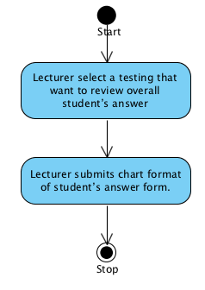

**System Requirement Specification of URS 20.1**

**SRS 20-1.1:** The system shall redirect to Chart format of student’s answer page on the web application.

**SRS 20-2.1:** The system shall fetch the assignment or quiz information from the system.

**SRS 20-3.1:** The system shall display overall student’s answer in each choice of assignment or quiz in chart format into Chart format of student’s answer page on the web application.

## **4.21 Lecturer can check whether the assignments are submitted in time. (UC 21.1)**

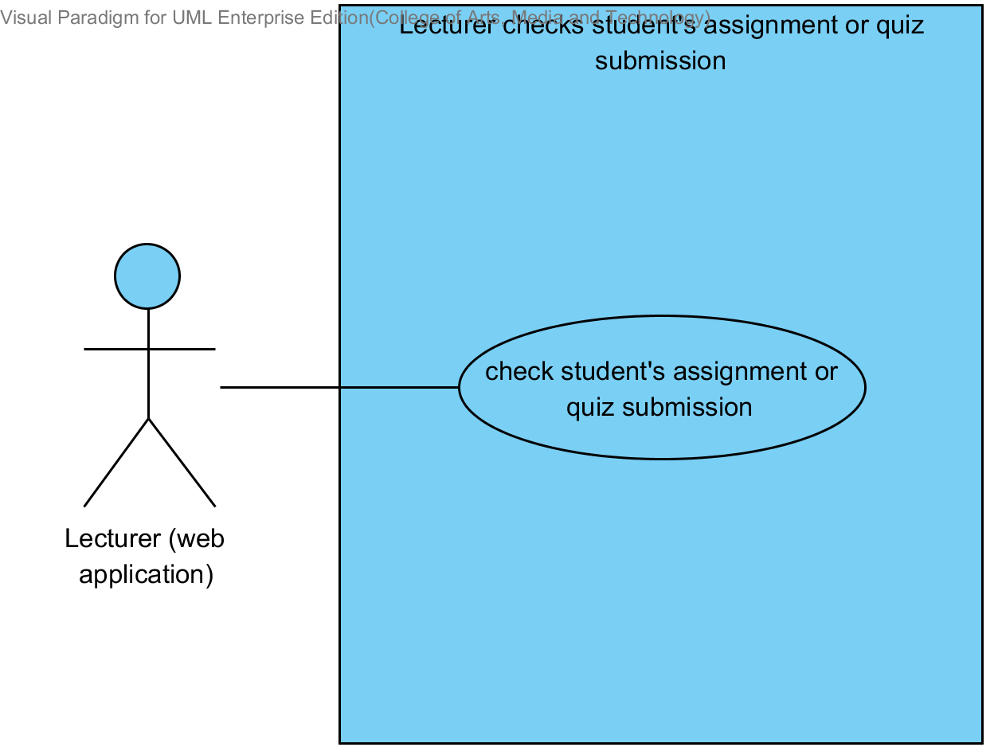

|  |  |  |  |  |
| --- | --- | --- | --- | --- |
| **Use Case ID:** | UC 21.1 | | | |
| **Use Case Name:** | Lecturer checks student’s assignment or quiz submission. | | | |
| **Created By:** | Mr.Tanadol Parn-ong | | **Last Updated By:** | Mr.Tanadol Parn-ong |
| **Date Created:** | 10/05/2014 | | **Last Revision Date:** | 10/05/2014 |
| **Actors:** | | Lecturer | | |
| **Description:** | | This use case is provided for Lecturer checks student’s assignment or quiz submission on the web application. | | |
| **Trigger:** | | Lecturer selects a testing that want to check students that submit assignments or quizzes. | | |
| **Preconditions:** | | Student have already finished taking the assignment or quiz and the answers are recorded in the system. | | |
| **Post conditions:** | | Lecturer can checks student’s assignment or quiz submission. | | |
| **Normal Flow:** | | 1. Lecturer selects a testing that want to check students that submit assignments or quizzes. 2. Lecturer submits submission status form. 3. The system redirects to testing submission page on the web application. 4. Lecturer clicks “submission in time” link. 5. The system displays testing submission information into testing submission page on the web application which consist student name, student ID. | | |
| **Alternative Flows:** | | 4A If Lecturer want to view students that does not submit assignments or quizzes in time.   1. Lecturer clicks “Not submission in time” link. 2. Use Case resumes on step 5 of normal flow | | |
| **Exceptions:** | | N/A | | |
| **Includes:** | | N/A | | |
| **Frequency of Use:** | | Often | | |
| **Assumptions:** | | N/A | | |
| **Notes and Issues:** | | N/A | | |

**URS 21.1 Lecturer can check whether the assignments are submitted in time.**

Lecturer can check whether who submitted an assignment or quiz in time into the web application. Also, who didn’t submit an assignment or quiz in time.

**Actor:** Lecturer

**Prerequisite:** Lecturer must have logged**.**

**Input:** None

**Flow of Execution:**

1. Lecturer selects a testing that want to check students that submit assignments or quizzes.
2. Lecturer submits submission status form.
3. Lecturer clicks “submission in time” link.

**Alternative flow**

3A If Lecturer want to view students that does not submit assignments or quizzes in time.

1. Lecturer clicks “Not submission in time” link.

**AC-21.1 Lecturer can check whether the assignments are submitted in time.**

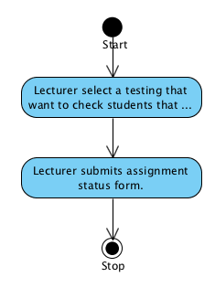

**System Requirement Specification of URS 21.1**

**SRS 21-1.1:** The system shall redirect to testing submission page on the web application.

**SRS 21-2.1:** The system displays testing submission information into testing submission page on the web application which consist student name, student ID.

## **4.22 Student can take assignments or quizzes which are multiple choices, true/false questions, short answers. (UC 22.1)**

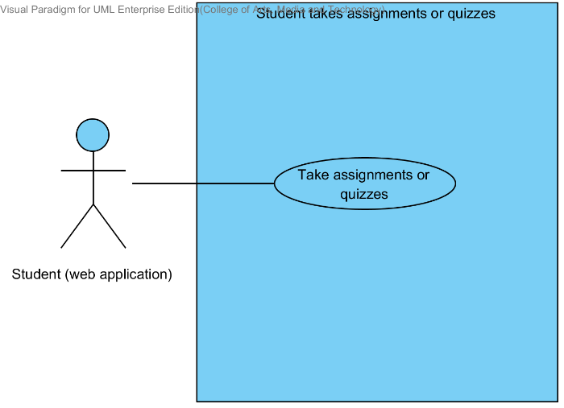

|  |  |  |  |  |
| --- | --- | --- | --- | --- |
| **Use Case ID:** | UC 22.1 | | | |
| **Use Case Name:** | Student takes assignments or quizzes | | | |
| **Created By:** | Mr.Tanadol Parn-ong | | **Last Updated By:** | Mr.Tanadol Parn-ong |
| **Date Created:** | 10/05/2014 | | **Last Revision Date:** | 10/05/2014 |
| **Actors:** | | Student | | |
| **Description:** | | This use case is provided for Student takes assignments or quizzes on the web application. | | |
| **Trigger:** | | Student enters to Overall testing page. | | |
| **Preconditions:** | | Student must logged in to the system. | | |
| **Post conditions:** | | The system stores answers of taking an assignment or quiz into the system. | | |
| **Normal Flow:** | | 1. Student enters to Overall testing page. 2. The system redirects to Overall testing page on the web application. 3. Student selects a testing that want to take an assignment or quiz. 4. Student submits taking assignment or quiz form. 5. Student enters to Assignment or quiz page. 6. The system redirects to Assignment or quiz page on the web application. 7. The system fetches the assignment or quiz information from the system. 8. The system displays the assignment or quiz information into Assignment or quiz page on the web application. 9. Student provides answers in every question. 10. Student submits answers. 11. The system stores answers of taking an assignment or quiz into the system. | | |
| **Alternative Flows:** | | N/A | | |
| **Exceptions:** | | N/A | | |
| **Includes:** | | N/A | | |
| **Frequency of Use:** | | Often | | |
| **Assumptions:** | | N/A | | |
| **Notes and Issues:** | | N/A | | |

**URS 22.1 Student can take assignments or quizzes which are multiple choices, true/false questions, short answers.**

Student can take assignments or quizzes which are multiple choices, true/false questions, short answers by using web application.

Student must provide answer information by separating from type of questions.

* Student can take multiple choices questions which provide one answer only in each order of questions.
* Student can take true/false questions which provide one answer only in each order of questions.
* Student can take short answers which provide characters or texts.

**Actor:** Student

**Prerequisite:** Student must have logged**.**

**Input:**

Multiple choices question

|  |  |  |  |
| --- | --- | --- | --- |
| Name | Description | Example | Remarks |
| multiple choices answer | Only “a, b, c, d” is allowed. | a |  |

True/false question

|  |  |  |  |
| --- | --- | --- | --- |
| Name | Description | Example | Remarks |
| true/false answer | Only “a, b, c, d” is allowed. | b |  |

Short answer

|  |  |  |  |
| --- | --- | --- | --- |
| Name | Description | Example | Remarks |
| short answer | Can be any character is allowed. | From the picture is a dog. |  |

**Flow of Execution:**

1. Student enters to Overall testing page.
2. Student selects a testing that want to take an assignment or quiz.
3. Student submits taking assignment or quiz form.
4. Student enters to Assignment or quiz page.
5. Student provides answers in every question.
6. Student submits answers.

**AC-22.1 Student can take assignments or quizzes which are multiple choices, true/false questions, short answers.**

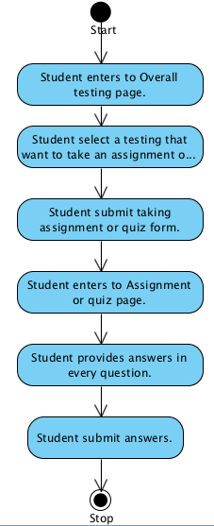

**System Requirement Specification of URS 22.1**

**SRS 22-1.1:** The system shall redirect to Overall testing page on the web application.

**SRS 22-2.1:** The system shall redirect to Assignment or quiz page on the web application.

**SRS 22-3.1:** The system shall fetch the assignment or quiz information from the system.

**SRS 22-4.1:** The system shall display the assignment or quiz information into Assignment or quiz page on the web application.

**SRS 22-5.1:** The system shall store answers of taking an assignment or quiz into the system.